

Faculty Advisor: Habiba Bougherara

Team Members

Gibrail Lashekham - xxx61056

Sanjiv Mohanraj - xxx47065

Arashdeep Dhaliwal - xxx64297

Joseph Alexander Small - xxx42616

**Bone plate: An Optimization Study Involving CAD Design, Computer Modeling, and Mechanical Tests**

# ACKNOWLEDGMENTS

Adamant Technologies would like to express our deepest and sincerest gratitude to all the individuals that have helped us complete this project. The team would like to specially thank Dr. Habiba Bougherara for allowing us the opportunity of working with her on this project, and as well as providing guidance and resources to the team. The team would also like to thank Saeed Manteghi for his guidance in manufacturing the bone plate, and also providing helpful feedback many times throughout the course of the project. The team would finally like to thank Professor Alan Machin for his help in using the lab equipment, and his supervision.

# ABSTRACT

The purpose of this study is to design, manufacture, and test a hybrid bone plate made of Flax/E-Glass/Epoxy composites to determine if it could be a valid substitute for current metallic fracture plates. The aim of the project was to specifically design the plate to improve bone healing. To achieve these results the plate would need to mimic the mechanical properties of the bone in order to prevent “stress shielding”. “Stress shielding” is a term used to describe the reduction in bone density as a result of the removal of typical stress from the bone. This can occur in the presence of an implant such as a bone plate where the majority of the load is transferred to the plate. The bone plate was designed to have two layers of E-Glass/Epoxy followed by 24 layers of Flax/Epoxy, and again another two layers of E-Glass/Epoxy, thus creating a “sandwich structure”.

The material properties for E-Glass/Epoxy and Flax/Epoxy were researched from online literature and previous studies. To optimize the design, optimal configurations for Carbon Fiber/Flax/Epoxy composites were studied. The optimal configuration from that study (C7) had an axial stiffness (4.2 MN), bending stiffness (13.3 Nm2), and torsional stiffness (21.8 Nm2). In this study, the same configuration yielded an axial stiffness of (1.4269 MN), bending stiffness of (4.9432 Nm2), and torsional stiffness of (7.8948 Nm2). A sample bone plate was then manufactured to test if the results for the stiffness’s were accurate. The theoretical value for the Young’s modulus was 14.1407 GPa and from the tension tests the modulus that was found was 18.474 GPa. The results of the study indicate the material properties of the laminate are similar to the properties of the human bone. Therefore it is a better option to reduce the effect of stress shielding that current materials being used such as stainless steel, and titanium, and could be considered as a possible candidate for bone plates in the near future.

# TABLE OF CONTENTS

ACKNOWLEDGMENTS iii

ABSTRACT iv

TABLE OF CONTENTS v

LIST OF FIGURES vii

LIST OF TABLES ix

NOMENCLATURE x

CHAPTER 1 - INTRODUCTION 1

1.1 Introduction 1

1.2 Project Description & Requirements 2

CHAPTER 2 - LITERATURE REVIEW 3

2.1 Types of Fractures for Femurs 4

2.2 Installation of Bone Plate 7

2.3 Forces That Act on the Femur 9

2.4 Healing & Biocompatibility 12

2.5 Mechanical & Material Properties 15

2.6 Laminate Theory 19

2.7 Testing Standards 24

CHAPTER 3 – CONCEPT DESIGN & EVALUATION 26

3.1 Determining E-Glass/Epoxy Lamina Properties Using Volume Fraction Calculations 26

3.2 Manufacturing and Testing Process 27

3.2.1 Laminate Manufacturing Process 27

3.2.2 E-Glass/Epoxy Plate Manufacturing 30

3.2.3 E-Glass/Epoxy/Flax Fiber Plate Manufacturing 30

3.2.4 Test Preparation 31

3.3 E-Glass/Epoxy Testing Results 33

3.4 Optimization of Laminate Stacking Sequence 35

3.5 Computational Analysis Via Finite Element Method 40

3.5.1 CAD Model 40

3.5.2 Material Properties 41

3.5.3 Finite Element Analysis 42

3.5.4 Computational Results 42

3.6 Testing of E-Glass/Flax/Epoxy Prototype 45

3.6.1 Tension Test Results 46

3.6.2 Bending Test Results 50

CHAPTER 4 – DISCUSSION & CONCLUSION 54

4.1 Comparison with existing designs 54

4.1.1 Contemporary Metals (Stainless Steel, Titanium), and Bone 54

4.1.2 Carbon-Fiber/Flax/Epoxy 55

4.2 Conclusion 57

4.3 Recommendations 58

REFERENCES 59

APPENDIX A - Miscellaneous Information 64

APPENDIX B - E-Glass/Epoxy Plate Manufacturing Process Flow Chart 65

APPENDIX C - Glass Fiber Post-Tensile-Testing 68

APPENDIX D - Detailed Drawings 71

APPENDIX E - ANSYS Workbench Results for Select Configurations 74

APPENDIX F - MATLAB Matrix Calculation for Stiffness 78

APPENDIX G - E-Glass/Flax/Epoxy Composite Post-Tensile-Testing 79

# LIST OF FIGURES

Figure 1 - Configuration of the Flax/CF/Epoxy Plate (new proposed composite material) 2

Figure 2 - Classification of Diaphyseal Femoral Fractures (Paschoal & Paccola, 2000) 4

Figure 3 - Intramedullary Nail and Bone Plate (Barwick, & Nowotarski, 2016) 5

Figure 4 - Vancouver Type Fractures (Duncan, Toms, & Masri, 2006) 6

Figure 5 - Different Type Of Bone Fractures Of The Femur Bone (Audigé, & Kellam,2016) 7

Figure 6 - X-Ray Visual Of A Bone Plate Fixed To The Femur Bone (raddaily.com,2016) 8

Figure 7 - Muscle and Joint Reaction Forces (Samiezadeh et al., 2015) 10

Figure 8 - Forces at a Femoral Fracture (Augat, Simon, Liedert, & Clacs, 2004) 12

Figure 9 - BIC values after testing intervals (Ballo et al., 2009) 14

Figure 10 - (a) Continuous Unidirectional (b) Discontinuous Unidirectional (c) Discontinuous and Random (Callister & Rethwisch, 2014). 15

Figure 11 - Lay-ups for Laminar Composites (a) UD (b) cross-ply (c) angle-ply (d) MD (Callister & Rethwisch, 2012) 16

Figure 12 - Tensile Specimen Geometry Requirements (ASTM, 2014) 25

Figure 13 - Tensile Specimen Geometry Recommendations (ASTM, 2014) 25

Figure 14 - 12x12 inch Flax Fiber Sheets 27

Figure 15 - Wrapped Base Plate with Silicone Tape borders 28

Figure 16 - Base Plate with Peeling Membrane 28

Figure 17 - Laying the second Peeling Membrane upon the composite layers 28

Figure 18 - Raking of Resin upon Flax Sheets 28

Figure 19 - Layering of Flax Sheets 28

Figure 20 - Mold Being Compressed Inside The Machine 29

Figure 21 - Mold Plate Inside The Membrane Bag, Loaded Into The Compression Molding Machine 29

Figure 22 - Compression Molding Process 29

Figure 23 - Composite Mold Plate Design 30

Figure 24 - Laminate Specimen Removed From The Mold Plate 31

Figure 25 - Radial Arm Saw Preparing Samples From Composite Plate 31

Figure 26 - Bending Test Samples, Composite Material 32

Figure 27 - Tensile Test Samples, Composite Material 32

Figure 28: Three-Point Bending Testing Set-up 32

Figure 29: Tensile Testing Set-up 32

Figure 30 - Stress- Strain Curve of 16 Layers Sample E-Glass/Epoxy Composite Acquired By Conducting Tensile Tests on Four Specimens 34

Figure 31 - CAD Model of Femur 40

Figure 32 - Major Muscle and Hip Joint Forces Applied to Femur 41

Figure 33 - Plate Surface Stress from configurations (a) C1 (b) C2 (c) C7 (d) C10 43

Figure 34 - Elastic (Linear) Portion of The Stress-Strain Curve Of E-Glass/Epoxy/Flax Composite Acquired By Conducting Tensile Tests On Five Specimens 46

Figure 35 - Specimen After Point Of Fracture Severed Into 2 Fragments 47

Figure 36 - E-Glass Fibers splitting after failure 48

Figure 37 - Force-Deflection Curve of E-Glass/Epoxy/Flax Composite Acquired By Conducting Three-Point Bending Tests on 5 Specimens with Fibers Running in the Longitudinal Direction 51

Figure 38 - Test Specimen After All Layers Have Failure 51

Figure 39 - Force-Deflection Curve Of E-Glass/Epoxy/Flax Composite Acquired by Conducting Three-Point Bending Tests on Five Specimens with Fibers Running Transverse Direction 53

Figure 40 - Table of Linear Elastic Material Properties (Samiezadeh et al., 2015) 54

Figure 41 - Glass Fiber Specimens After Tensile Tests 68

Figure 42 - Fracture of Specimen A03 69

Figure 43 - Exploded View of Specimen A03 69

Figure 44 - Exploded View Of Specimen A04 70

Figure 45 - Cross Section View Of Specimen At Fracture Point 70

Figure 46 - Base Assembly Design Drawing 72

Figure 47 - Bone Plate Design Drawing 73

Figure 48 - Bone Surface Stress Simulation Solution for C1 74

Figure 49 - Plate Stress Simulation Solution for C1 74

Figure 50 - Total Deformation Simulation Solution for C1 75

Figure 51 - Plate Deformation Simulation Solution for C1 75

Figure 52 - Bone Surface Stress Simulation Solution for C7 76

Figure 53 - Plate Stress Simulation Solution for C7 76

Figure 54 - Total Deformation Simulation Solution for C7 77

Figure 55 - Plate Deformation Simulation Solution for C7 77

Figure 56 - Top View Fracture of Specimen 2 79

Figure 57 - Top View Fracture of Specimen 3 79

Figure 58 - Left View Fracture of Specimen 3 80

Figure 59 - Fracture of Specimen 4 80

# LIST OF TABLES

Table 1 - Material Properties found in literature 26

Table 2 - Tensile Test Attained Properties of Specimens of E-Glass/Epoxy composite (SI units) 34

Table 3 - Stacking Sequence of Optimized Configurations from Previous Study 36

Table 4 - Material Properties Determined from Section 3.1 36

Table 5 - Axial Stiffness EA, Bending Stiffness EI, Torsional Stiffness GJ Per Configuration 38

Table 6 - Corresponding Modulus Ex, Ey, and G Calculated from Table 5 39

Table 7 - Force Components for Muscle and Joint Reaction Forces 41

Table 8 - Linear Elastic Material Properties Used in computational analysis (Samiezadeh et al, 2014) 42

Table 9 - Major Results Obtained Through ANSYS Workbench 43

Table 10 - Tensile Test Attained Properties of Specimens of E-Glass/Epoxy/Flax Composite 47

Table 11 - Properties Collected From Conducting Bending Test of Specimens of E-Glass/Epoxy/Flax Composite Running In The Longitudinal Direction 52

Table 12 - Properties Collected From Conducting Bending Test of Specimens of E-Glass/Epoxy/Flax Composite Running In The Transverse Direction 54

Table 13 - Carbon-Fiber/Flax/Epoxy Stiffness Results from Previous Study (Samiezadeh et al, 2014) 56

Table 14 - Major Results Obtained Through ANSYS Workbench for E-Glass & Carbon Fiber 57

# NOMENCLATURE

|  |  |  |  |
| --- | --- | --- | --- |
| Symbol | Description | Greek Symbol | Description |
| E | Young’s Modulus | $$σ$$ | Stress |
| *V* | Volume | $$σ_{U}^{l}$$ | Ultimate Tensile Strength |
| *G* | Shear Modulus | $$σ_{U}^{f}$$ | Ultimate Flexural Strength |
| *EI* | Bending Stiffness | $$τ$$ | Shear Stress |
| *EA* | Axial Stiffness | $$ε$$ | Strain |
| *GJ* | Torsional Stiffness | $$γ$$ | Shear Strain |
| $$Q$$ | Stiffness Coefficient | *v* | Poisson’s Ratio |
| $$k$$ | Curvature | $$θ$$ | Angle to reference ply |
| A | Extensional Stiffness Matrix | $$α$$ | Inverse of Extensional Stiffness Matrix |
| B | Coupling Stiffness Matrix | $$β$$ | Inverse of Coupling Stiffness Matrix |
| D | Bending Stiffness Matrix | $$δ$$ | Inverse of Bending Stiffness Matrix |
| T | Torque |
| *SEF* | Stiffness Efficiency Factor |
| z | Location of ply with respect to z-axis |
| *A* | Cross Sectional Area |
| *I* | Moment of Inertia |
| *J* | Polar Moment of Interia |
| *d* | Depth |
| *b* | Width |
| $$N$$ | Force resultant |
| $$M$$ | Moment resultant |

**Subscripts**

|  |  |  |  |
| --- | --- | --- | --- |
| Symbol | Description | Symbol | Description |
| x | With respect to the x-direction | xx | Represents location in matrix |
| y | With respect to the y-direction | yy | Represents location in matrix |
| z | With respect to the z-direction | xy | Represents location in matrix |
| o | No in-plane strains (pure bending case) | ss | Represents location in matrix |
| L | Longitudinal orientation | T | Transverse orientation |
| f | Fiber material properties | m | Matrix material properties |

# CHAPTER 1 - INTRODUCTION

## Introduction

Within the medical profession, bone plates have been used for many years by experts as a standard practice to assist in the healing of broken or fractured bones. Bone plates can be seen as internal splints, which help hold the bone in place during the recovery process. They are currently made from either titanium or stainless steel, mostly due to the high corrosion resistance and biocompatibility of these materials. This is necessary because when foreign materials are introduced into the body, the host’s body may reject the new material, which may cause harmful reactions such as irritation/inflammation, and possibly even death. Bodily fluids consist of a warm solution containing 1 wt% NaCl in addition to other salt and organic components. This creates a corrosive environment, which for metal alloys, can lead to corrosion; and while under stresses can lead to stress corrosion, cracking, and fatigue (Callister & Rethwisch, 2012).

Currently in the medical industry, new materials are being looked into to replace metallic bone plates, one example would be composite materials such as carbon fiber. Material scientists are investigating the use of several composites in various configurations to improve bone healing and resolve the issue of “stress shielding”. Stress shielding occurs when the bone plate carries the majority of the load that would normally be on the femur and leaves the femur with very light loading. As a result, the stress is not transferred to the bone and limits the bone’s recovery, which makes the bone prone to re-fracture. Based on research studies, in order to reduce stress shielding, the axial stiffness of the plate must be reduced, since the femur experiences axial stresses more than others. Thus an indicator of a good design will be one that reduces axial stiffness, but is high with respect to bending and torsional stiffness.

## Project Description & Requirements

The objective of this project is to design, optimize, and manufacture a hybrid composite bone plate made of glass fiber, flax, and epoxy shown in Figure 1. The design of the bone plate will be specifically for a human femur. Before designing the bone plate, research on current studies with similar parameters to this project will be looked into. Once a design has been made, the team will perform simulations and lab tests to measure the material the properties. After which, the properties will be compared to other designs and to human bone itself to determine how it measures against the other designs.

It should be noted that this project is not innovative, but an iteration of previous studies on bone plates. The specific studies are on the “Optimization of a composite bone plate using the selective stress shielding approach”, and “Biomechanical properties of an advanced new carbon/flax/epoxy composite material for bone plate applications”. Throughout the paper these studies will be considered as the reference design.

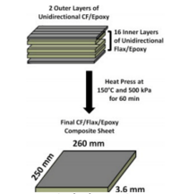

Figure 1 - Configuration of the Flax/CF/Epoxy Plate (new proposed composite material)

# CHAPTER 2 - LITERATURE REVIEW

To design and assess the new bone plate laminate, it is vital to understand the interactions between the bone plate and the patient’s body once implanted. Factors to consider are not just the mechanical properties of the material, but also the biocompatibility. Further information on the intended purpose of the bone plate, as well as the scenarios in which would be required is also beneficial to the overall understanding of the project’s scope. This section covers research on the following topics; the types of fractures, the situations where a bone plate needs to be installed, the forces that are experienced by the femur and implant while in use, the biocompatibility of the E-glass with the human body and relevant information concerning the anatomy of the femoral region.

## 2.1 Types of Fractures for Femurs

The femur is the longest as well as the strongest bone in the human body. To analyze the femur, it is generally split into three regions, being the proximal, medial and distal portions. Any break along the femur is called a femoral shaft fracture of which there five main types (Barwick, & Nowotarski, 2011).

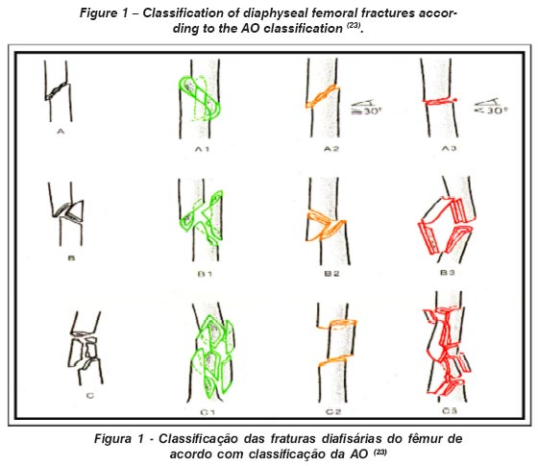

Figure 2 - Classification of Diaphyseal Femoral Fractures (Paschoal & Paccola, 2000)

As seen in Figure 2, a transverse fracture is horizontal across the bone while an oblique fracture is angled across the bone. A spiral fracture encircles the bone, similar to the stripes on a candy cane as depicted in Figure 2. More complicated fractures are like the comminuted fractures in Figure 4 where the bone is broken into 3 or more pieces. The last variety of fracture is an Open/Compound fracture where the bone actually penetrates the skin.

Typically, an intramedullary nail would be implanted to correct such fractures, except for the compound fracture where external bracing would need to be used. Though the nail is the more commonly used method, the bone plate is necessary in situations where the nail cannot be implanted. Both methods are shown in Figure 3. The bone plate is particularly useful for periprosthetic fractures, which are fractures that occur on a bone that already have an implant in them. In our case, it would be the femur and the patient would have received a hip implant. These fractures are usually diaphyseal (around the mid-section of the bone) and occur near the stem of the hip implant (Barwick, & Nowotarski, 2011).

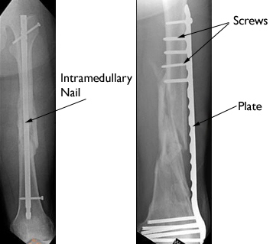

Figure 3 - Intramedullary Nail and Bone Plate (Barwick, & Nowotarski, 2016)

There are several varieties of periprosthetic fractures that occur around the femur and hip; which are classified as Vancouver type fractures. Vancouver type fractures occur after total hip arthroplasty and vary based on location and fracture type. Vancouver A type fractures occur on the proximal part of the femur and are a displacement of the greater or lesser Trochanter as outlined in Figure 4. There are three sub-series of Vancouver B type as shown in Figures 4b-d. Vancouver B1 fractures occur around the femoral stem or just distal to the stem. B2 fractures occur proximal or distal to a loose femoral stem that have an adequate amount of proximal bone attached to the stem. The final type in this sub-series is the B3 fracture that occurs around or just distal to a loose femoral, except unlike the B2 fracture, there is a poor proximal bone stock. The last classification of Vancouver fracture is type C which occurs fairly distal to the tip of the stem implant. Of all these fractures, only types A, B1 and C allow there to be Open Reduction internal Fixation (ORIF); which is essentially open surgery to realign the bone by means of installing a prosthetic.

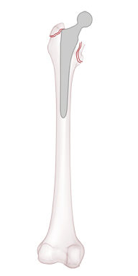 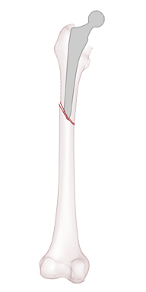 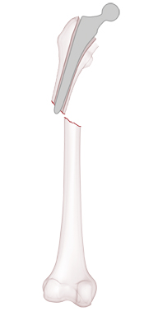 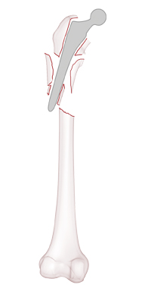 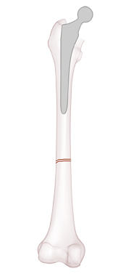

a b c d e

Figure 4 - Vancouver Type Fractures (Duncan, Toms, & Masri, 2006)

For the purpose of this project, our team is using the same experimental settings as our reference. The fracture of focus in our testing scenario is the Vancouver B1 fracture, since this fracture accounts for approximately 80% of periprosthetic leg fractures in elderly patients (Bagheri et al., 2014; Rockwood et al., 2010). The fracture types we will pay specific attention to are the transverse and two variations of oblique fractures. The first condition for the oblique fracture is a 60 degree fracture from the proximal lateral to the distal medial portion of the femur; while the second is a 60 degree fracture from the proximal medial to the distal lateral portion of the bone. This second scenario is more critical, since it has been measured to have higher shear forces and less compressive forces; which affect the integrity of the plate as well as the development of the near bone.

## 2.2 Installation of Bone Plate

Bone plates are one of many surgical tools employed to assist with the fixation, reduction and healing of the femur. The specific tool employed varies depending on the condition of the fracture; however in most cases where the fracture is clean (Row A in Figure 5) installing a bone plate is the preferred method of fixation.

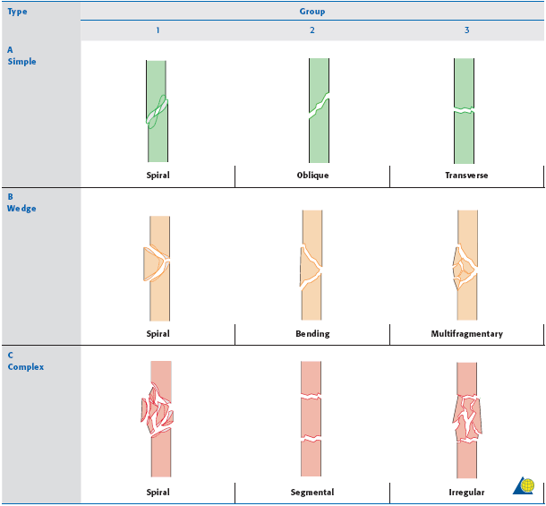

Figure 5 - Different Type Of Bone Fractures Of The Femur Bone (Audigé, & Kellam, 2016)

In addition, installing a bone plate is the optimum healing technique when the fractured femur ends are misaligned from one another. Furthermore, bone plates are readily employed in situations where the patient already has a hip implant in place. In this case it becomes impossible to drive a nail through the middle of the bone to attach both halves, as the hip joint covers the ideal nail insertion point. In cases where the bone shatters (bending fracture) into many pieces, bone plates cannot be used as they cannot easily anchor small individual pieces. In these scenarios multiple techniques are utilized to reduce the bone.

The installation of the bone plate requires open surgery; the surgeon cuts into the thigh to expose all or certain segments of the bone depending on the condition of the breakage. The bone is then reset into its neutral position and the bone plate is placed along the length of the broken and aligned into positon. Once properly positioned, the plate is screwed into place to affix it to the bone itself. Figure 6 illustrates a titanium plate affixed to the femur to help in the healing of a fracture.

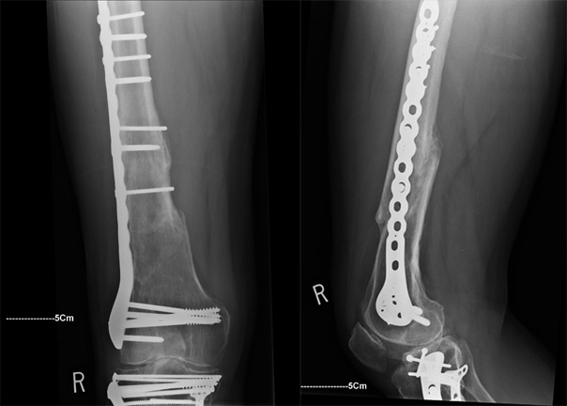

Figure 6 - X-Ray Visual of a Bone Plate Fixed to the Femur Bone (raddaily.com, 2016)

Utilizing this technique delivers favorable results and it is effective in treating all manners of breakages. However, this technique has some drawbacks, mainly regarding the tensile conditioning of the bone. When the plate is affixed to the bone it holds it under slight pressure compressing it; which helps the healing process of the bone. Only a few days after installation of a plate, the compression force of the plate dissipates and the healing process slows down drastically. The loss of compression in the bone leads to further issues, such as weak repair joint. The embedded bone plate withholds all the loading on the fractured bone segment, this results in the healed area being weak as it never receives any loading or stress.

## 2.3 Forces That Act on the Femur

The internal forces that act upon the plate are very important in considering the material selection and the manufacturing process. Within the leg, the femur experiences loading from the weight of the body, as well as joint contact forces at the hip and muscle forces that act upon the femur. There are several modes of movement that are simulated for testing purposes. The Gait cycle is a single-legged stance repetitive loading operation that represents the walking process. There are three stages involved which are: 1) the heel strike, 2) the mid-stance and 3) the toe off. There are also extreme loading conditions that are simulated for the sake of safety such as the peak forces during the ascension of stairs and variations of this loading condition (Cheal, Spector, & Hayes, 1992).

There are several muscle groups that affect the femur through different modes of operation. The consideration of muscle and joint forces are important for simulations through finite element analysis (FEA) due to the contributions made to the total force acting upon the bone and plate. Some important muscles to consider are: the Adductor Longus, Adductor Magnus, Gluteus Minimus, Gluteus Medius, Gluteus Maximus and Psoas to name a few. The analysis of the force components are very important for the FEA and the determination of the muscles involved are also important as seen in Appendix A (Cheal, Spector, & Hayes, 1992). In our reference document, only a few muscles forces are considered along with the hip joint force as displayed in Figure 7. Our team will use the same considerations in our approach to analyzing the loading conditions.

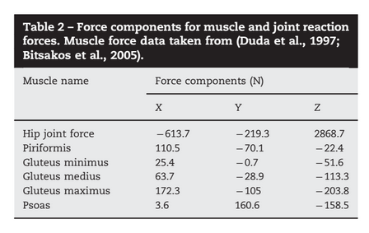

Figure 7 - Muscle and Joint Reaction Forces (Samiezadeh et al., 2015)

There are many types of forces that act upon the femur in several areas depending on the loading conditions. Generally, the femur is loaded axially, but it also experiences bending, torsion and shear stresses. To determine the effects of these loading scenarios, FEA simulations were performed on a model femur that had undergone total hip arthroplasty. The results of these simulations showed that the primary mode of deformation during the three phase Gait cycle was bending in the anterior-medial direction. Even though this bending was the primary form of deformation, the overall deformation was more so seen on the distal sections of bone during the cycle (Cheal, Spector, & Hayes, 1992).

During the extreme conditions testing, the simulation of the extension of the flexed hip (stair ascension) resulted in bending in the posterior lateral direction. Force analysis of the flexion of the extended hip resulted in bending in the anterior- lateral direction. Bending in the posterior-medial direction was observed in the simulations of adduction of the abducted hip. Unlike the other extreme conditions, external rotation of the neutral hip resulted in primarily axial compression with only a small bending component. The conclusion reached through this line of testing was that during the Gait cycle, the in-plane bending is greater than the out of plane bending. This observed result was opposite in the stair ascension scenarios. Another notable result was that the axial forces experienced decreased through the progression of the Gait cycle. Relations between the different types of forces were also observed in different bone sections. Shear stress related to axial components of force at the bone implant interface, while at the distal region of the stem shear stresses related to the torsional forces (Cheal, Spector, & Hayes, 1992).

Further inclusion of the muscular activity in the FEA result in changes in the magnitude and critical areas of forces experienced by the femur. It was observed, it was observed that the bending moments were smaller within this testing scenario compared to tests that put less focus on the inclusion of soft tissue effects. It was also noted that with the reduction of loading due to the inclusion of muscle groups in the calculations, there was also an increase in error in the calculations. This indicates that there is still a lot of research that needs to be done concerning the extent of the role muscles play in these types of calculations. FEA results from that experiment were that the femur experiences alternating bending loads during the Gait cycle. Also, that the highest shear was calculated to be at the proximal and distal ends of the femur. Other notable results were; internal loads were reduced towards the diaphyseal section of the femur and that shear stresses/forces in these sections were near zero due to muscular forces. The walking process also results in small torsional moments within the femur (Duda, Schneider , & Chao, 1997).

## 2.4 Healing & Biocompatibility

Factors that affect the recovery process of femoral fractures are; mechanical, biological and biomechanical. Additional important material factors include: surface configuration/topography and cell bonding capabilities (Albrektsson & Johansson, 2001). The bulk material properties are responsible for the mechanical and structural properties of the bone plate, while the surface properties can be attributed to the biocompatibility characteristics.

There are several mechanical factors that affect fracture healing, but the main factors are: fracture type, geometry, magnitude, direction and fragmentation. As previously explained within this report, there are many forces that are applied on the femur. Recovery advancement or delay is conditional relative to the forces experienced and the area they are focused on. From the results of several different studies performed it was found that the local stress and strain at the fracture site could not be measured. Therefore global mechanical factors had to be considered; which are why FEA models are vital. Figure 8 shows the forces that act upon the femur near the fracture site.

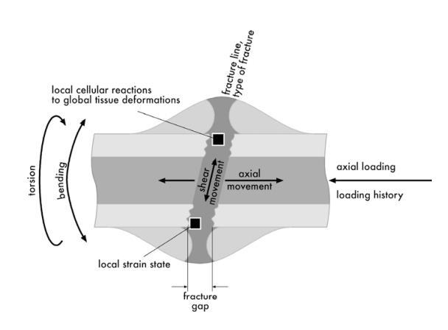

Figure 8 - Forces at a Femoral Fracture (Augat, Simon, Liedert, & Clacs, 2004)

Mechanical forces acting on a fracture have biomechanical effects on the growth process. This is important to know since the surgical attachment of a bone plate affects the distribution of forces over the femur. Rigid fixation causes compression at the fracture site; the osteosynthesis at the fracture gap leads to osteonal bridging at the fracture and ultimately results in direct bone formation and healing. Through various studies it has been proven that compressive loads are beneficial in the callus formation process as well as encouraging the formation of endochondral bone. Although there are downsides to stiff fixation such as the limitation of callus formation at the fracture; which can be better achieved by the flexible fixation of a bone stem. The formation and growth of these bone tissues are initiated by osteoblasts and osteocytes; which are cells that respond to mechanical stimuli (Augat et al., 2004; Bartel et al., 2006; Kim et al., 2010; Samiezadeh et al., 2014).

There is still considerable research that needs to be done to fully understand what causes the cells to react the way they do and how to control their function. Through lab trials, it has been observed that moderate compressive inter-fragmentary movements in the axial direction (<2mm) promotes the creation of periosteal callus, resulting in faster healing times (Aro et al., 1993; Kenwright et al., 1991; Larsson et al., 2001). Shear, bending and tensile stresses also have observable effects on the recovery process. In some tests, shear movement at the fracture site results in superior healing compared to axial movement. At other times it actually worsens the recovery process through the creation of fibrous tissue that either delays union or causes a non-union. Bending stiffness is also a leading factor concerning the stability of fractures. Thus, shear bending and tensile stresses are commonly noted to not help as much as compressive loads during the healing process (Aro et al., 1993; Augat et al, 2003; Bishop et al, 2002; Park et al, 1998; Sarmiento et al, 1996; Woo et al., 1984).

One important characteristic is osseointegration; which is needed for good and direct bone bonding. To achieve good osseointegration, a material requires a high bone-to-implant contact (BIC). Poor bonding between the implant and bone leads to the development of fibrous tissue at the interface; which is detrimental to proper fracture healing (Soballe et al., 1991). Studies done on porcine tibia have proven that fiber-reinforced composites are better adapted for the physiological requirements need for proper bone growth due to their strength and elasticity (Vallittu, 1999; Lassila et al., 2002). Further studies proved that FRC’s enhanced with bioactive glass (BAG) performed even better. As seen in Figure 9, the FRC/BAG sample had better BIC; which promoted uniform bone formation and growth in addition to having a larger bonding area and stronger bond (Ballo et al., 2009).

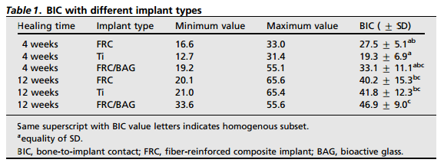

Figure 9 - BIC values after testing intervals (Ballo et al., 2009)

Another important biocompatibility factor is the cytotoxicity of the material. This encompasses any negative reactions the body may have due to the introduction of the implant material into the body. Through *in vitro* studies performed, it was determined that E-glass reinforced polymers are non-cytotoxic and that E-glass is optimal for enhancing polymers due to its high adhesion. Studies on human gingival fibroblasts have shown that both treated and non-treated E-glass have no cytotoxic effects and also facilitate the growth of cells at a similar rate as standard cell culture plate (Väkiparta, Koskinen, Vallittu, Närhi & Yli-Urpo, 2004).

## 2.5 Mechanical & Material Properties

Composites have shown improvements to mechanical characteristics such as stiffness, and high-temperature strength, over traditional materials. Composites are considered to be any multiphase material that exhibits a significant proportion of the properties of both constituent phases such that a better combination of properties is realized. (Callister & Rethwisch, 2014). These composites are artificially made, as opposed to materials that are formed naturally. Many composites materials are composed of two phases, the matrix and the dispersed phase. The matrix is a continuous medium that surrounds the dispersed phase. There are many classifications of composites, ranging from fiber-reinforced composites to nanocomposites. For this report, we are dealing with structural composites, which will be discussed shortly.

Fiber orientation plays a huge role in the overall mechanical properties of the composite. The arrangement of the fibers relative to one another provides two extreme conditions, a parallel alignment in the longitudinal axis of the fibers in one direction or a totally random alignment as shown in Figure 10 (Callister & Rethwisch, 2014).

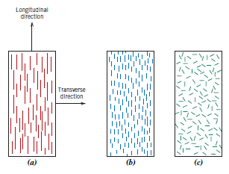

Figure 10 - (a) Continuous Unidirectional (b) Discontinuous Unidirectional (c) Discontinuous and Random (Callister & Rethwisch, 2014).

Laminar Composites (a structural composite) are composed of two-dimensional sheets, called laminae or plies, stacked on one another. Each ply has a preferred high-strength direction. Laminate properties are dependent on the orientation of each ply. Figure 11 below illustrates the four classes of laminates. Unidirectional (UD) laminates provides a single high-strength direction, whereas the other orientations will have several high-strength directions.

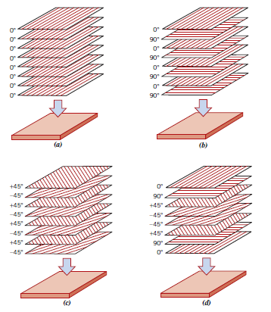

Figure 11 - Lay-ups for Laminar Composites (a) UD (b) cross-ply (c) angle-ply (d) MD (Callister & Rethwisch, 2012)

Mechanical Properties of laminar composites can be found using a variety of methods, including both theoretical and experimental approaches. These characteristics depend on the properties of the fiber, degree of load transmittance to fiber by the matrix phase, and the interfacial bond between matrix and fiber. (Callister & Rethwisch, 2012)

Composite materials are not generally isotropic. That is, the physical properties are not independent of the direction of applied force. Longitudinal (axial) loading along fiber direction will generally provide a very strong fiber-matrix interfacial bond, whereas transverse loading (normal to fibers) will provide lower properties since the weaker matrix is not shielded from carrying stress by the fibers to the same degree as for axial loading (Clyne, 2000). This effect is carried over if the laminate plate is Unidirectional. Having all laminae in the same direction will significantly strengthen any axial property, but will also show significantly lower properties in the transverse direction. Cross-plying each ply will help to provide equal properties in both directions if desired.

For this project, the goal for the team is to lower the longitudinal properties of the composite plate while increasing its transverse properties. In other words, we must decrease the axial stiffness while increasing flexural stiffness. Doing so will increase the amount of stress transferred to the bone which will reduce the effect of stress-shielding, while also being stiff enough in the transverse direction to prevent further damage occurring through an injury.

Experimentally, properties such as stiffness and ultimate strength can be found using multiple methods. For instance, a tension test can be used to find the axial stiffness and the ultimate strength in the longitudinal direction, whereas a bending test will provide both the flexural stiffness and flexural strength. Section 2.6.0 (Testing) goes further into detail on testing a specimen for mechanical properties as well as standards and requirements

The main reason glass fibers are being used is because it is less stiff than carbon fiber, which will lend a hand in lowering the all-important longitudinal stress of the composite. Glass fibers are a popular choice in many applications in the automotive, plastic pipes, storage containers, and industrial floorings industries due to the following reasons. (Callister & Rethwisch, 2014)

1. Easily drawn into high-strength fibers from molten state

2. Readily available and may be fabricated into a glass-reinforced plastic economically using a wide variety of composite-manufacturing techniques

3. As a fiber it is relatively strong, when embedded in a plastic matrix, it produces a composite having a very high specific strength

4. When coupled with various plastics, it possesses a chemical inertness that renders the composite useful in a variety of corrosive environments.

A drawback on glass fibers is that they are limited to service temperatures below 200oC. At higher temperatures it will begin to deteriorate. To understand the derivation of the mechanical behaviours of a Laminate Composite, one must first have a grasp on the stress-strain relationship for principle directions, and the definition of an orthotropic material. An orthotropic material is one with at least two orthogonal planes of symmetry, and the material properties are independent of direction within each plane. These materials require 9 independent variables in their constitutive matrices. There are still many variables to work with. However, since each lamina is a thin layer, they can be treated as a plane-stress problem, which is an engineering concept that assumes a small principal stress in a third direction is zero, effectively simplifying a three-dimensional stress-problem into two dimensions. In this case, the zero principal stress is oriented in the z-direction. Doing so reduces the independent variables from 9 to 4. It also reduces the stiffness matrix size from 6x6 to 3x3 ("eFunda: Stress-Strain Relations of Materials", 2016). This is further discussed in the Section 2.6 Laminate Theory, which will also provide a step by step process to ultimately determine the stiffness equations.

## 2.6 Laminate Theory

In order to evaluate how well the bone plate reduces the stress at the fracture site, the stiffness of the composite laminate has to be calculated. In order to derive the stiffness, classical laminate theory was utilized. A laminate is defined as a stack of unidirectional composite plies. Within the stack, each of the composite plies can be stacked at a different angle to produce various results for the laminate’s stiffness.

Since the design uses composite materials, the assumption of using isotropic materials is invalid, hence the assumption of orthotropic materials is used to simplify calculations because it requires only 4 elastic constants (Ex, Ey, Gxy, νxy), whereas anisotropic materials could require possibly 21 constants (Kassapoglou, 2016). In addition, because the laminate is thin, it is assumed the stress and shear stresses related to the z-axis are equivalent to zero (σz = τyz = τxz = 0). To find the stresses for a 2D ply Eq. 1 – 5 are utilized.

$$\left[\begin{matrix}\begin{matrix}σ_{x} \\ σ_{y} \\ τ_{xy}\end{matrix}\end{matrix}\right]=\left[\begin{matrix}Q_{xx} & Q_{xy} & 0 \\ Q_{xy} & Q_{yy} & 0 \\ 0 & 0 & Q_{ss}\end{matrix}\right]\left[\begin{matrix}ε_{x} \\ ε_{y} \\ γ_{xy}\end{matrix}\right] Eq.1$$

$$Q_{xx}=\left(\frac{E_{L}}{1-v_{LT}v_{TL}}\right) Eq. 2$$

$$Q_{yy}=\left(\frac{E_{T}}{1-v_{LT}v_{TL}}\right) Eq. 3$$

$$Q_{xy}=\left(\frac{v_{LT}E_{T}}{1-v_{LT}v_{TL}}\right)= \left(\frac{v_{TL}E_{L}}{1-v_{LT}v_{TL}}\right) Eq. 4$$

$$Q_{ss}=G_{LT} Eq. 5$$

When a ply is orientated at a different angle (θ) than the reference ply, the stresses will need to be transformed so that all the stresses are aligned within the same coordinate system (typically the longitudinal and transverse directions). To transform the stresses Eqs. 6 – 15 are used.

$$\left[\begin{matrix}\begin{matrix}σ_{L} \\ σ_{T} \\ τ_{LT}\end{matrix}\end{matrix}\right]=\left[\begin{matrix}{(cos{θ)}}^{2} & {(sin{θ)}}^{2} & 2sinθcosθ \\ {(sin{θ)}}^{2} & {(cos{θ)}}^{2} & -2sinθcosθ \\ -sinθcosθ & sinθcosθ & {((cos{θ)}}^{2}- {(sin{θ)}}^{2})\end{matrix}\right]\left[\begin{matrix}\begin{matrix}σ_{x} \\ σ_{y} \\ τ_{xy}\end{matrix}\end{matrix}\right] Eq. 6$$

m= $(cos{θ)} Eq. 7$

n = $(sin{θ)} Eq. 8$

$$Q_{11}^{θ}= m^{4}Q_{xx}+n^{4}Q_{yy}+{2m^{2}n}^{2}Q_{xy}+{4m^{2}n}^{2}Q_{ss} Eq. 9$$

$$Q_{22}^{θ}= n^{4}Q_{xx}+m^{4}Q_{yy}+{2m^{2}n}^{2}Q_{xy}+{4m^{2}n}^{2}Q_{ss} Eq. 10$$

$$Q_{12}^{θ}= {m^{2}n}^{2}Q_{xx}+{m^{2}n}^{2}Q_{yy}+{(m^{4}+n}^{4})Q_{xy}-{4m^{2}n}^{2}Q_{ss} Eq. 11$$

$$Q_{66}^{θ}= {m^{2}n}^{2}Q_{xx}+{m^{2}n}^{2}Q_{yy}-{2m^{2}n}^{2}Q_{xy}+{{(m^{2}-n}^{2})}^{2}Q_{ss} Eq. 12$$

$$Q_{16}^{θ}= m^{3}nQ_{xx}-mn^{3}Q_{yy}+\left(mn^{3}-m^{3}n\right)Q_{xy}+2\left(mn^{3}-m^{3}n\right)Q_{ss} Eq. 13$$

$$Q_{26}^{θ}= mn^{3}Q_{xx}+m^{3}nQ_{yy}+\left(m^{3}n-mn^{3}\right)Q_{xy}+2\left(m^{3}n-mn^{3}\right)Q_{ss} Eq. 14$$

$$\left[\begin{matrix}\begin{matrix}σ_{L} \\ σ_{T} \\ τ_{LT}\end{matrix}\end{matrix}\right]=\left[\begin{matrix}Q_{11} & Q_{12} & Q_{16} \\ Q_{12} & Q_{22} & Q_{26} \\ Q_{16} & Q_{26} & Q_{66}\end{matrix}\right]\left[\begin{matrix}ε_{L} \\ ε_{T} \\ γ_{LT}\end{matrix}\right] Eq. 15$$

Although the stress-strain relationship can be found using the equations provided, the stresses in a laminate vary from layer to layer (Agarwal et al., 2006). Therefore, the equation will be modified, so that stress is replaced by force and moment resultants (the resultant is force and moment per unit width). The force and moment resultants for the laminate are shown in Eq. 16.

$$\left[\begin{matrix}\begin{matrix}N_{x} \\ N_{y} \\ N_{xy} \\ M_{x} \\ M_{y} \\ M_{xy}\end{matrix}\end{matrix}\right]=\left[\begin{matrix}A_{11} & A_{12} & A_{16} & B_{11} & B_{12} & B_{16} \\ A_{12} & A_{22} & A_{26} & B_{12} & B_{22} & B_{26} \\ A_{16} & A_{26} & A_{66} & B_{16} & B_{26} & B_{66} \\ B_{11} & B_{12} & B_{16} & D_{11} & D_{12} & D_{16} \\ B_{12} & B_{22} & B_{26} & D_{12} & D_{22} & D_{26} \\ B_{16} & B_{26} & B_{66} & D_{16} & D_{26} & D_{66}\end{matrix}\right]\left[\begin{matrix}ε_{xo} \\ ε_{yo} \\ γ_{xyo} \\ k_{x} \\ k_{y} \\ k_{xy}\end{matrix}\right] Eq. 16$$

Where A is the extensional stiffness matrix, B is the coupling stiffness matrix, and D is the bending stiffness matrix ("eFunda: Classical Lamination Theory", 2016). Another assumption that is made is that the laminate is symmetric in order to simplify calculations; which in result make the B matrix equal to 0. In addition, it is assumed the laminate is balanced (which means for each ply stacked at +θ, there is a ply stacked at -θ), as a result A16, A26 are also equal to 0 (Kassapoglou, 2016).

$$A_{ij}= \sum_{k=1}^{N}{{\left(Q_{ij}\right)}^{\left(k\right)}\left(z_{k}-z_{k-1}\right) Eq. 17}$$

$$B_{ij}=\frac{1}{2} \sum_{k=1}^{N}{{\left(Q_{ij}\right)}^{\left(k\right)}({z_{k}}^{2}-{z_{k-1}}^{2})} Eq. 18$$

$$D_{ij}=\frac{1}{3} \sum_{k=1}^{N}{{\left(Q_{ij}\right)}^{\left(k\right)}\left({z_{k}}^{3}-{z_{k-1}}^{3}\right) Eq. 19}$$

To obtain the midplane strains and plate curvatures, Eq. 16 will need to be rearranged. Thus, a new equation will be created to represent the inverted stress-strain relationship; which is represented in Eq. 20. The team has generated a MATLAB code (Appendix 6.1.1) to calculate the results for the midplane strain and plate curvatures, using arbitrary values until all required values have been obtained.

$$\left[\begin{matrix}ε_{xo} \\ ε_{yo} \\ γ_{xyo} \\ k_{x} \\ k_{y} \\ k_{xy}\end{matrix}\right]=\left[\begin{matrix}α_{11} & α_{12} & α_{16} & β_{11} & β_{12} & β_{16} \\ α_{12} & α_{22} & α_{26} & β_{12} & β_{22} & β_{26} \\ α_{16} & α_{26} & α_{66} & β_{16} & β_{26} & β_{66} \\ β_{11} & β_{12} & β_{16} & δ_{11} & δ_{12} & δ_{16} \\ β_{12} & β_{22} & β_{26} & δ_{12} & δ_{22} & δ_{26} \\ β_{16} & β_{26} & β_{66} & δ_{16} & δ_{26} & δ_{66}\end{matrix}\right]\left[\begin{matrix}\begin{matrix}N_{x} \\ N_{y} \\ N_{xy} \\ M_{x} \\ M_{y} \\ M_{xy}\end{matrix}\end{matrix}\right] Eq. 20$$

$$\left[\begin{matrix}α\end{matrix}\right]={\left[A\right]}^{-1}+{\left[A\right]}^{-1}\left[B\right]{ \left[[D\right]-\left[B\right]{\left[A\right]}^{-1} [B]]}^{-1} \left[B\right]{\left[A\right]}^{-1} Eq. 21$$

$$\left[\begin{matrix}β\end{matrix}\right]=-{\left[A\right]}^{-1}\left[B\right]{ \left[[D\right]-\left[B\right]{\left[A\right]}^{-1} [B]]}^{-1} Eq. 22$$

$$\left[\begin{matrix}δ\end{matrix}\right]={\left[[D\right]-\left[B\right]{\left[A\right]}^{-1} [B]]}^{-1} Eq. 23$$

Once the midplane strains and plate curvatures are found for the given loads, it can be substituted into Eq. 24 to obtain the strain in the laminae. Then the strain of the laminae needs to be transformed to the same coordinate system as the reference laminae, which can be done by using Eq. 25, where θ is the angle of the laminae to the reference laminae.

$$\left[\begin{matrix}\begin{matrix}ε_{x} \\ ε_{y} \\ γ_{xy}\end{matrix}\end{matrix}\right]=\left[\begin{matrix}ε_{xo} \\ ε_{yo} \\ γ_{xyo}\end{matrix}\right]+z\left[\begin{matrix}k_{x} \\ k_{y} \\ k_{xy}\end{matrix}\right] Eq . 24$$

$$\left[\begin{matrix}\begin{matrix}ε_{L} \\ ε_{T} \\ γ_{LT}\end{matrix}\end{matrix}\right]=\left[\begin{matrix}{(cos{θ)}}^{2} & {(sin{θ)}}^{2} & sinθcosθ \\ {(sin{θ)}}^{2} & {(cos{θ)}}^{2} & -sinθcosθ \\ -2sinθcosθ & 2sinθcosθ & {((cos{θ)}}^{2}- {(sin{θ)}}^{2})\end{matrix}\right]\left[\begin{matrix}ε_{x} \\ ε_{y} \\ γ_{xy}\end{matrix}\right] Eq. 25$$

Now that the strain has been transformed to the same coordinate system as the reference laminae, the stresses can be determined by substituting the values from Eq. 25 into Eq. 26. By following this procedure the values for stresses and strains in all laminae can be found for the laminate (Agarwal et al., 2006).

$$\left[\begin{matrix}\begin{matrix}σ_{L} \\ σ_{T} \\ τ_{LT}\end{matrix}\end{matrix}\right]=\left[\begin{matrix}Q_{xx} & Q_{xy} & 0 \\ Q_{xy} & Q_{yy} & 0 \\ 0 & 0 & Q_{ss}\end{matrix}\right]\left[\begin{matrix}ε_{L} \\ ε_{T} \\ γ_{LT}\end{matrix}\right] Eq. 26$$

Since the goal of this project is to design a bone plate that will improve fracture healing, the design should aim to minimize axial stiffness. Therefore, to evaluate stiffness the bone plate is treated as a beam, and the stress-strain relationship derived above is compared to the stiffness matrix of an isotropic beam (Kollar & Springer, 2003). The stiffness matrix of an orthotropic beam is as follows:

$$\left[\begin{matrix}\begin{matrix}\hat{N} \\ \hat{M_{y}} \\ \hat{M_{z}} \\ \hat{T}\end{matrix}\end{matrix}\right]=\left[\begin{matrix}\hat{EA} & 0 & 0 & 0 \\ 0 & \hat{{EI}_{yy}} & \hat{{EI}_{yz}} & 0 \\ 0 & \hat{{EI}_{yz}} & \hat{{EI}_{zz}} & 0 \\ 0 & 0 & 0 & \hat{GJ}\end{matrix}\right]\left[\begin{matrix}ε_{x}^{0} \\ \begin{matrix}k_{x} \\ k_{y} \\ k_{xy}\end{matrix}\end{matrix}\right] Eq. 30$$

To obtain the axial stiffness, it is assumed that Nx is the only force that acts on the laminate and that the length to width ratio is high (Samiezadeh et al., 2015). From the midplane strain obtained in Eq.31 the axial stiffness can be found using Eq.34 where b is the width of the laminate (Samiezadeh et al., 2015). The bending stiffness is obtained by assuming a pure bending moment in the x-z plane (My) is applied and that the beam is narrow. The curvature of the midplane in the x-z plane from Eq. 32 can be used to find the bending stiffness in Eq. 35 (Samiezadeh et al., 2015). To obtain the torsional stiffness it is assumed that any applied torque on the beam results in a twist moment (Mxy) and subsequent shear flow. Furthermore, it is assumed that the change in width due to shear is negligible, and that no axial force or bending moment are applied on the beam. As a result, the out-of-plane curvature is found using Eq. 33, which leads to the torsional stiffness being found by using Eq. 36 and Eq. 37 (Samiezadeh et al., 2015).

$$ε_{x}^{0}= α_{11}N_{x} Eq. 31$$

$$k_{x}= δ_{11}M_{x } Eq. 32$$

$$k_{xy}= -\frac{1}{2}δ_{66}M_{xy} Eq. 33$$

$$EA= b/{α_{11}} Eq. 34$$

$$EI_{yy}= b/{δ_{11}} Eq. 35$$

$$T= -2bM_{xy} Eq. 36$$

$$GJ= {4b}/{δ_{11}} Eq. 37$$

Once the results are obtained, the stiffness can be compared to other bone plates made of different materials such as carbon fiber, or titanium to see which design is beneficial for bone healing.

## 2.7 Testing Standards

In addition to designing the bone plate, the team is required to perform tests on the bone plate for; tension, compression, torsion and bending. With the results obtained from the experiment, the values can be compared to the theoretical and simulated values that the team found. The comparison can determine if the design of the bone plate is accurate, and how it will perform in real-world applications. To assure the tests are credible, the team sought for engineering standards for testing composite materials. The ensuing are standards that were found for the tests.

1. Tension
   1. ASTM D3039 Tensile Testing for Advanced Composite Materials
2. Compression
   1. ASTM D6641 Compression Properties of Polymer Matrix Composite Materials Using a Combined Loading Compression (CLC) Test Fixture
   2. ASTM D5467 Compression Properties of Unidirectional Polymer Matrix Composite Materials Using a Sandwich Beam
3. Bending
   1. ASTM D7264 Flexural Test Equipment for Polymer Matrix Composite Materials

According to ASTM D3039, if the stress-strain response can be determined, then: ultimate tensile strain, tensile modulus of elasticity, Poisson’s ratio, and transition strain can be derived (ASTM, 2014). The ASTM D7264 is used to determine the flexural strength, flexural stiffness, and deflection behavior (ASTM, 2015). Both standards require that at least five specimens should be tested unless valid results can be gained by using fewer specimens. The list of requirements for specimen shape, dimensions and tolerances is shown in Figure 12 (ASTM, 2014) and the recommend geometry is given in Figure 13 (ASTM, 2014). Further procedures, requirements, and calculations are listed in the ASTM D3039 and ASTM D7264 document, and will be referred to when the team starts to manufacture the design due to the large amount of content. During the project the team discovered that compression and torsion testing machines were unavailable. The team consulted with Dr. Bougherara, and was told to ignore those project requirements and to focus on tension and bending tests.



Figure 12 - Tensile Specimen Geometry Requirements (ASTM, 2014)



Figure 13 - Tensile Specimen Geometry Recommendations (ASTM, 2014)

# CHAPTER 3 – CONCEPT DESIGN & EVALUATION

## 3.1 Determining E-Glass/Epoxy Lamina Properties Using Volume Fraction Calculations

In order to evaluate the laminate the team will be using, the material properties need to be determined first. The team obtained the mechanical properties (E1, E2, G, ν) of Flax/epoxy from a previous study (Samiezadeh et al., 2015). However the following is the procedure the team used in order to obtain the mechanical properties E-Glass/Epoxy.

The first task was to create a fiber-reinforced composite lamina between the E-Glass and the Epoxy. Using eFunda’s Volume Fraction Calculator ("eFunda: Estimation of Lamina Material Constants", 2016), assuming 50% Volume Fraction of fiber and inputting individual material properties (Table 1) found in literature, eFunda calculated the following properties;

Table 1 - Material Properties found in literature

|  |  |  |  |  |
| --- | --- | --- | --- | --- |
|  | *Ef* (GPA) | *Gf* (GPA) | *vf* (GPA) | Source |
| E-Glass | 77 | 33 | 0.22 | (Korsil, 2007) |
| Epoxy | 2.6 | 2.7 | 0.35 | (Azom.com, 2016) |

Young’s Modulus along the fiber direction *E1*

Young’s Modulus transverse to the fiber direction *E2*

Shear Modulus *G12*

Major Poisson’s Ratio

$$v_{1}=V_{f}v_{f}+V_{m}v_{m}=0.28$$

## 3.2 Manufacturing and Testing Process

### 3.2.1 Laminate Manufacturing Process

To verify the mechanical properties of the test materials, as well as final composite material, prototype samples were manufactured. This fabrication process consists of creating the mold and then forming the plate.

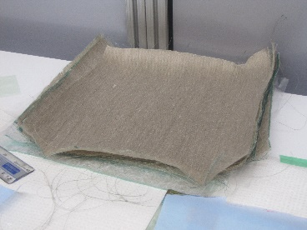To create the laminate plate, first 12x12 inch sheets of the chosen material were cut from a stock roll of unidirectional fiber using a basic pair of scissors (Figure 14). The fiber alignment of the material when cut was equivalent to 90o. The manufacturing mold was then created to house the fiber sheets. The mold consists of two 15x15 inch aluminum plates, heat resistant silicone tape, silicone sealant, heat resistant tape peeling membrane and a high temperature resistant membrane.

Figure 14 - 12x12 inch Flax Fiber Sheets

The aluminum plates were wrapped with the high temperature membrane and sealed with the heat resistant tape to protect it from potential resin leaking out during the compression process. A 12x12 inch square was then drawn in the center of the base plate to mark the placement location of the fiber sheets. On the perimeter of this drawn square, the silicone tape was layered in a basic weave pattern to create a border (Figure 15). This border would serve to keep the plate in place during the compression process as well as mitigate resin leakage. The height of this border is dependent upon the amount of layers being used to form the plate. The silicone tape border is then sealed using a silicone sealant to further increase its stability and resistance to leaking. The final step in creating the mold is to cut two 12x12 inch squares of the peeling membrane (Figure 16). This material is utilized so that the finished plate can be easily extracted from the mold.

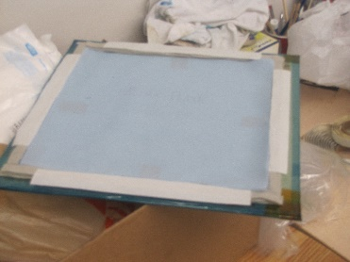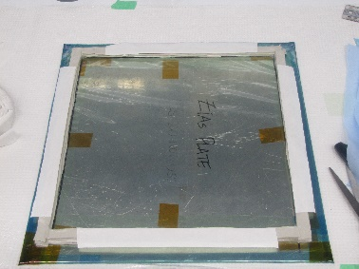

Figure 15 - Wrapped Base Plate with Silicone Tape borders

Figure 16 - Base Plate with Peeling Membrane

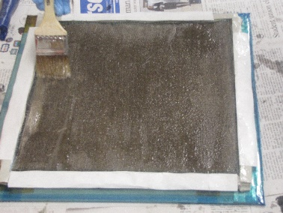After the mold was completed, the resin mixture was then formulated. The resin consisted of a 20-80 solution of Aradur 22962 hardener and Araldite LY564 epoxy resin. 600g of resin was required, which meant that 120g of hardener was used and 480g of epoxy resin was used. One should note that after initially combining the two liquids the mixture is opaque and needs to be further stirred until it becomes a clear solution.

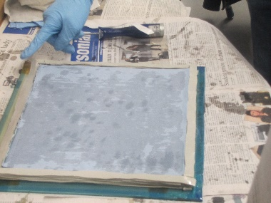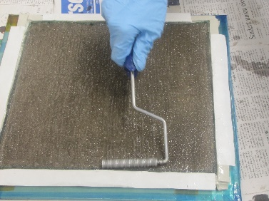

Figure 17 - Laying the second Peeling Membrane upon the composite layers

Figure 18 - Raking of Resin upon Flax Sheets

Figure 19 - Layering of Flax Sheets

To create the plate, one piece of the peeling membrane was placed inside the borders of the mold and covered in the resin mix. The fiber sheets were then layered upon one another, ensuring that the fibers of the sheet ran in the desired direction based on the specific configuration. In between each layer, the resin mixture was evenly spread using a brush (Figure 17), and then raked with a ridged roller to create small ridges to aid in adhesion (Figure 18). Once the final sheet was placed, resin was again spread on top of it and the second peeling membrane square was placed on top off the stack of fiber layers (Figure 19). To close the mold, the second wrapped aluminum plate was placed upon the base which housed the layered fiber sheets.

Before commencing the laminate forming stage of the manufacturing process, a bag is created using the high temperature resistant membrane and heat resistant tape. The purpose of this bag is to contain the laminate plate during the compression molding process, as well as collect the resin that escapes the mold. This protects the machine from the leaking fluid. The mold was then placed within the bag, which had already been installed inside the machine and the bag was then sealed using the heat resistant tape.

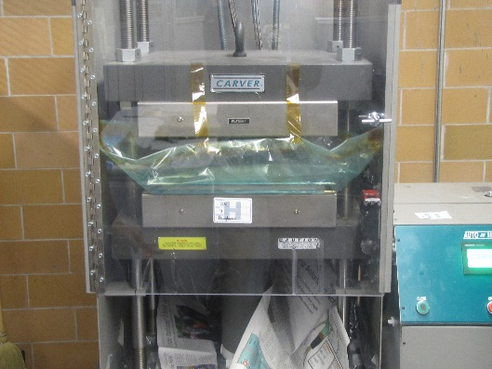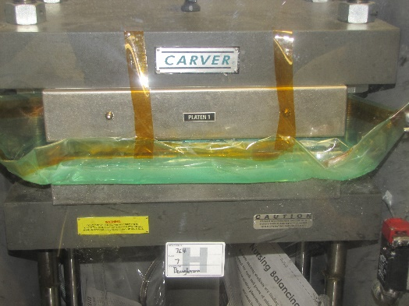

Figure 20 - Mold Being Compressed Inside The Machine

Figure 21 - Mold Plate Inside The Membrane Bag, Loaded Into The Compression Molding Machine

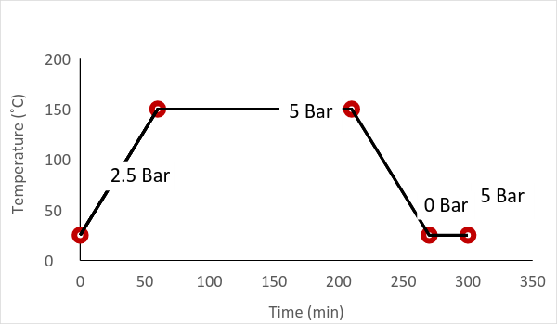To cure the plate, the compression molding machine was set to certain specifications for this type of operation. The compression molding process involves three stages: heating, curing and cooling as shown in Figure 22. During the heating stage, the mold was put under a pressure of 2.5 bar, which is half of the maximum pressure being used. The mold was also gradually heated to 150oC from room temperature. Once the temperature was at 150oC, the mold was then put under 5 bar of constant pressure for 150 minutes. After this time frame, the mold was allowed to cool inside the machine, while being kept under 5 bar of constant pressure. When room temperature was reached, the pressure on the mold was released and the compression mold machine allowed removal of the completed laminate specimen.

Figure 22 - Compression Molding Process

### 3.2.2 E-Glass/Epoxy Plate Manufacturing

Once the theoretical mechanical properties of the E-Glass/Epoxy composite were calculated, a sample was manufactured to test and verify the results. The creation of this test sample involved the simple layering of the fiber sheets, while following the procedure explained above. Since the E-Glass/Epoxy sample was only needed to validate the theoretical results, a simple unidirectional plate was created consisting of 16 layers.

### 3.2.3 E-Glass/Epoxy/Flax Fiber Plate Manufacturing

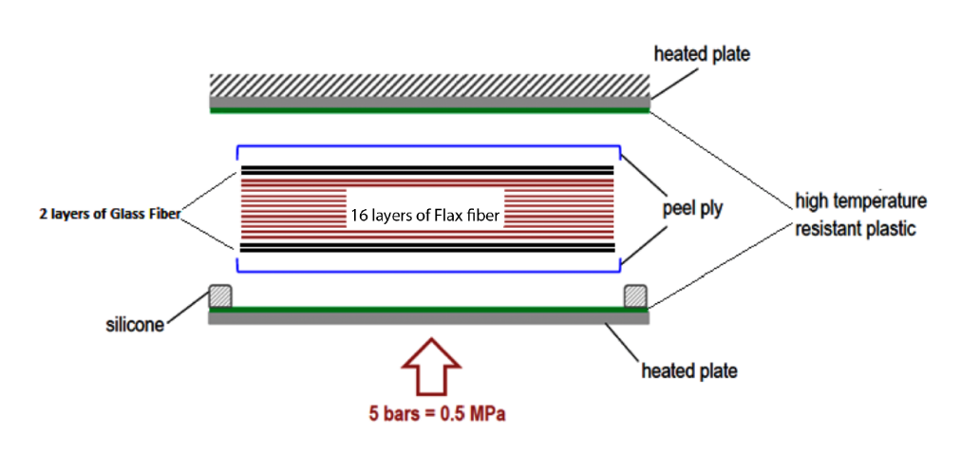After creating several configurations of E-Glass/Epoxy/Flax fiber composite, a configuration was chosen to manufacture and test to validate the theoretical results. Configuration H1 was chosen based on layering complexity and testing constraints that limited the overall thickness of the sample. To create the Flax fiber sheets with the fibers running at a 45o angle, the stock sheet was cut along that angle to the required dimensions (12x12 inches). Layering the Composite sheets were different compared to the E-Glass/Epoxy sample due to the specific required orientation of the sheets, as well as the order the materials were layered in. The composite plate involved sandwiching the Flax fibers in between the E-Glass fibers, which make up the outsides of the plate. Due to the limitations of the testing apparatus, the E-Glass/Epoxy/Flax Fiber plate could only be manufactured to have a total of twenty layers.

Figure 23 - Composite Mold Plate Design

### 3.2.4 Test Preparation

To perform the necessary tensile and bending tests, the laminate specimens needed to be prepared into smaller sample sizes based on the ASTM standards for each respective test. From the manufacturing process, the laminate plates were covered by excess resin and silicone tape that had oozed out of the mold during the compression molding process (Figure 24). To remove the now hardened resin, scissors and other shearing tools were employed to cut away the hardened material, while ensuring that the laminate plate underneath was not damaged.

Figure 24 - Laminate Specimen Removed From The Mold Plate

To cut the specimens into testable samples, a radial arm saw was utilized (Figure 25). The specimens were cut along the 0o as well as 90o directions to attain both longitudinal and transverse test samples. Samples for the tensile test were cut to be 250mm long and 25mm wide (Figure 27). For the 3-point bending tests, the ratio of the support span to specimen thickness is 32:1. Since the specimens were approximately 5mm thick, the support span length was 160mm. The overall length of the specimen was 277.8125, while the width was the standard 13mm (Figure 28). Since the composite specimen did not fall within the ASTM nominal standards, based on Note 3, there was the possibility of unexpected deviations that could affect the neutral axis due to the laminate stacking sequence.

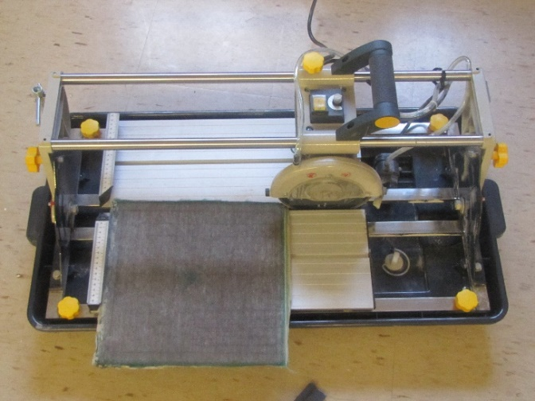

Figure 25 - Radial Arm Saw Preparing Samples From Composite Plate

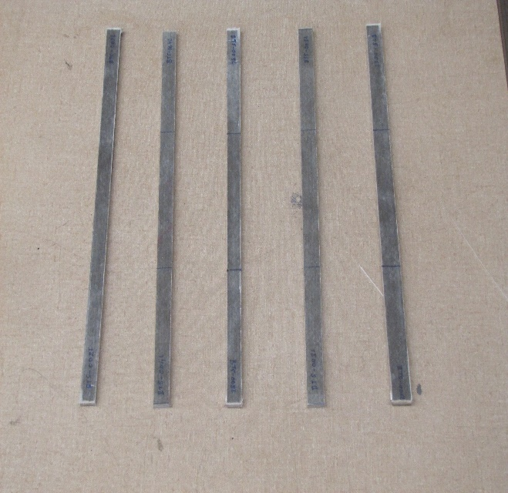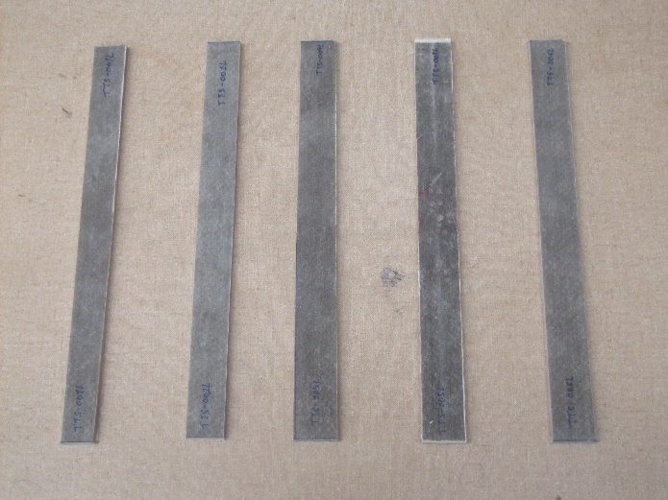

Figure 26 - Bending Test Samples, Composite Material

Figure 27 - Tensile Test Samples, Composite Material

To perform the two tests, a tensile testing machine equipped with a 20,000lb load cell was used. For the 3-point bending test, the testing program was set to have a load application rate of 10mm/minute. Appropriate modifications were made to the apparatus set-up to perform each line of testing as shown in Figures 28 and 29.

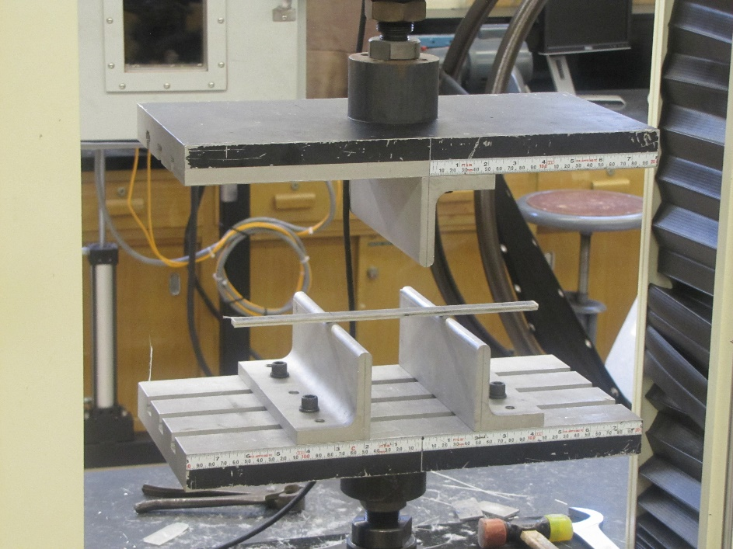

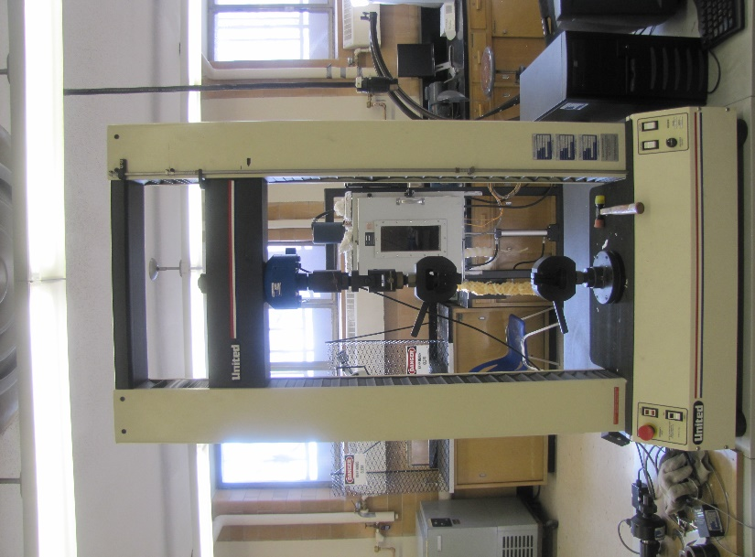

Figure 28: Three-Point Bending Testing Set-up

Figure 29: Tensile Testing Set-up

## 3.3 E-Glass/Epoxy Testing Results

A square “plate” was manufactured containing 16 layers of E-Glass/Epoxy, the plate cut using a diamond tooth circular saw, 3 specimens rectangular profile, 8 inches by 1 inch were cut from the plate in the longitudinal direction. Specimens were tensile tested to determine properties of E-glass material properties, more specifically the longitudinal modulus (E1). The results obtained were consistent as seen in Table 2, the modulus ranged from 6,750,844 psi (46.545 GPa) to 7,717,064 (53.207 GPa). The mean modulus was calculated to be 7,488,880 psi (51.634 GPa), with the standard deviation of 556460 psi (3.837 GPa). As seen in Figure 30 the result of the tested exhibited a linear positive sloping line during the elastic region, however the lines deviation slightly from complete linearity. Subsequent to the elastic phase the material was tested for applied load but not strain hence the vertical line in Figure 30, the material was tested until failure. Result from the experiment show material modulus of 51.63 GPa which was very similar to the theoretically attained value 39.8 GPa

Figure 30 - Stress- Strain Curve of 16 Layers Sample E-Glass/Epoxy Composite Acquired By Conducting Tensile Tests on Four Specimens

Table 2 - Tensile Test Attained Properties of Specimens of E-Glass/Epoxy composite (SI units)

|  |  |  |  |
| --- | --- | --- | --- |
| Specimen ID | Tensile Strength (Kg) | Tensile Strength (GPa) | Modulus (GPa) |
| A01 | 4,773 | 0.606 | 51.199 |
| A02 | 7,142 | 0.924 | 46.545 |
| A03 | 7,326 | 0.832 | 55.584 |
| A04 | 5,694 | 0.621 | 53.207 |
| MEAN | 6,234 | 0.746 | 51.634 |
| Std. Dev | 1,217 | 0.157 | 3.837 |

## 3.4 Optimization of Laminate Stacking Sequence

The variables that affect the design of the bone plate are; material, number of materials, number of plies, and the stacking sequence of the laminate. Since the project outline has already constrained what materials, and how many materials and plies are being used, the only way to optimize the design is to change the stacking sequence. To limit the number of configurations for the stacking sequence a previous study on the optimization process was looked into to find out what the criteria was. In order for the configuration be considered in must meet all of the following requirements (Samiezadeh et al., 2015):

1. Were symmetric about the midsurface.
2. Were balanced.
3. Contained $\overline{+}$ 45° plies at their outer surfaces.
4. Had greater than 10% of 0° and 90° plies.
5. Had 60% or less of plies in any direction.
6. Had at least six 90° plies at the midsurface.

To limit the number of configurations, the only ply angles that were considered were (0°, -45°, 45°, and 90°), and only half of the plies were taken into account due to symmetry.

From the previous study on the optimization process, it was found that the possible configurations were categorized in intervals of 1 Nm2 based on their bending stiffness. From the interval, each configuration with the highest Stiffness Efficiency Factor (SEF) was chosen (Samiezadeh et al., 2015). The SEF is an equation (Eq. 38) that is designed to find the configuration with the minimum axial stiffness and maximum torsional stiffness within the interval.

$${SEF}_{i}=0.5\left(\frac{{EA}_{min}}{{EA}_{i}}\right)+0.5\left(\frac{{GJ}_{i}}{{GJ}_{max}}\right) Eq. 38$$

Due to the unforeseen difficulties the team had decided that it was best to utilize the same optimized configurations as the previous study (Samiezadeh et al., 2015). This method would provide a fair comparison between the new results and the results from the previous research. The following were the configurations for the Carbon-Fiber/Flax/Epoxy laminate that the team decided to compare.

Table 3 - Stacking Sequence of Optimized Configurations from Previous Study

|  |  |
| --- | --- |
| Configuration | Stacking Sequence |
| C1 | [0C/08F]s |
| C2 | [452/45/0/-45/0/45/0/-45/903]s |
| C6 | [45/02/+452/0/45/903]s |
| C7 | [45/02/45/0/-452/452/-45/903]s |
| C8 | [45/02/45/0/-452/45/0/904]s |
| C9 | [45/02/45/02/-452/45/904]s |
| C10 | [45/04/+452/904]s |

To obtain the stiffness values of the laminate, the team utilized eFunda’s Stiffness Matrix Calculator ("Calculator for Stiffness and Compliance of Laminate: Layout", 2016). Using the material properties determined in Section 3.1, listed in Table 4, the extensional stiffness matrix (A), coupling stiffness matrix (B), and bending stiffness matrix (D), were found. The following matrices are based on the 28 layer unidirectional (0°) laminate as a sample calculation.

Table 4 - Material Properties Determined from Section 3.1

|  |  |  |
| --- | --- | --- |
| Material Property | Flax/Epoxy | E-Glass/Epoxy |
| Young’s Modulus along Fibers (GPa) | 35 | 39.8 |
| Young’s Modulus normal to Fibers (GPa) | 4.4 | 5.03 |
| Shear Modulus (GPa) | 2.1 | 4.99 |
| Poisson’s ratio | 0.3 | 0.28 |
| Thickness (mm) | 0.2 | 0.2 |

$$\left[A\right]=\left[\begin{matrix}A_{11} & A_{12} & A_{16} \\ A_{12} & A_{22} & A_{26} \\ A_{16} & A_{26} & A_{36}\end{matrix}\right]= \left[\begin{matrix}206.7 & 8.857 & 0 \\ 8.857 & 29.52 & 0 \\ 0 & 0 & 14.08\end{matrix}\right] GPa∙mm$$

$$\left[B\right]=\left[\begin{matrix}B_{11} & B_{12} & B_{16} \\ B_{12} & B_{22} & B_{26} \\ B_{16} & B_{26} & B_{36}\end{matrix}\right]= \left[\begin{matrix}0 & 0 & 0 \\ 0 & 0 & 0 \\ 0 & 0 & 0\end{matrix}\right] GPa∙{mm}^{2}$$

$$\left[D\right]=\left[\begin{matrix}D_{11} & D_{12} & D_{16} \\ D_{12} & D_{22} & D_{26} \\ D_{16} & D_{26} & D_{36}\end{matrix}\right]=\left[\begin{matrix}575.1 & 28.89 & 0 \\ 28.89 & 96.31 & 0 \\ 0 & 0 & 46.45\end{matrix}\right] GPa∙{mm}^{3}$$

After the completion of the stiffness matrices, the final step is to finally calculate the axial stiffness, bending stiffness, and torsional stiffness. Following the procedure outlined under the Laminate Theory section and with the aid of MATLAB code developed by Sanjiv Mohanraj (code in Appendix F) the inverse stiffness matrices could be solved for;

$$[α]= \left[\begin{matrix}0.0049 & -0.0015 & 0 \\ -0.0015 & 0.0343 & 0 \\ 0 & 0 & 0.0710\end{matrix}\right]$$

$$[δ]= \left[\begin{matrix}0.0018 & -0.0005 & 0 \\ -0.0005 & 0.0105 & 0 \\ 0 & 0 & 0.0215\end{matrix}\right]$$

Solving for the stiffness values; (width = b = 0.01697 m)

Axial Stiffness $EA= b/{α_{11}}=b/{0.0049}= 3.4626$ MN

Bending Stiffness Nm2

Torsional Stiffness Nm2

Using the calculation method above and the stacking sequence listed in Table 5, Eq. 34, 35 and 37, the stiffness could be determined and are listed in Table 5. The configurations that begin with C were created to compare the results of the configurations in Table 3. The configurations that start with G were created due to the fact that the team couldn’t cut the available E-Glass fibers at 45°. Due to limitations on the testing apparatus available to the team, the thickness of the laminate had to be decreased, thus configuration H1 was created. Due to these limitations all G and H configurations do not satisfy all the optimization conditions mentioned above (specifically condition 3 and 6). Therefore the H1 configuration will only look to compare the experimental results to its simulated results.

Table 5 - Axial Stiffness EA, Bending Stiffness EI, Torsional Stiffness GJ Per Configuration

|  |  |  |  |  |
| --- | --- | --- | --- | --- |
| Configuration | Stacking Sequence | EA (MN) | EI (Nm2) | GJ (Nm2) |
| C1 | [014]s | 3.4626 | 9.6124 | 3.1530 |
| C2 | [452/45/0/-45/0/45/0/-45/903]s | 1.4269 | 3.5704 | 9.3024 |
| C6 | [45/02/+452/0/45/903]s | 1.4269 | 4.6239 | 8.221 |
| C7 | [45/02/45/0/-452/452/-45/903]s | 1.4269 | 4.9432 | 7.8948 |
| C8 | [45/02/45/0/-452/45/0/904]s | 1.5927 | 5.1125 | 7.636 |
| C9 | [45/02/45/02/-452/45/904]s | 1.5927 | 5.3845 | 7.3572 |
| C10 | [45/04/+452/904]s | 1.5927 | 5.6399 | 7.0922 |
| G1 | [02/45/02/+45/02/904]s | 1.9037 | 6.4723 | 5.8161 |
| G2 | [902/453/-453/02/904]s | 1.1039 | 2.3756 | 6.8922 |
| G3 | [02/-453/453/03/903]s | 1.7485 | 5.3027 | 6.8743 |
| G4 | [04/+45/0/45/02/903]s | 2.1027 | 7.3481 | 4.9874 |
| G5 | [902/45/90/-45/90/-45/90/45/905]s | 0.619 | 1.736 | 5.5636 |
| H1 | [02/+45/02/45/902]s | 1.3462 | 2.4961 | 2.1861 |

*‘s’ indicates each stacking sequence is symmetric at the last ply mentioned

Solving for the Young’s modulus and Shear modulus; (depth = d = 0.0056m)

$$A= d x b = 8.636e-05 m2$$

$$I = {db^{3}}/{12}=1.8572e-10 m^{4}$$

$$J= \left({db}/{12} \right)\left(d^{2}+b^{2}\right)=2.26556e-09 m^{4}$$

$$E_{x}= {EA}/{1e03∙A} Eq.39$$

$$E_{y}= {EI}/{1e9∙I} Eq.40$$

$$G= {GJ}/{1e9∙J} Eq.41$$

Table 6 - Corresponding Modulus Ex, Ey, and G Calculated from Table 5

|  |  |  |  |
| --- | --- | --- | --- |
| Configuration | Ex (GPa) | Ey (GPa) | G (GPa) |
| C1 | 36.43592 | 38.70503 | 1.242798 |
| C2 | 14.98844 | 14.35109 | 3.660168 |
| C6 | 14.98844 | 18.58560 | 3.234675 |
| C7 | 14.98844 | 19.86901 | 3.106326 |
| C8 | 16.73004 | 20.54951 | 3.004498 |
| C9 | 16.73004 | 21.64280 | 2.894800 |
| C10 | 16.73004 | 22.66938 | 2.79053 |
| G1 | 19.99684 | 26.01518 | 2.288431 |
| G2 | 11.59558 | 9.548640 | 2.711838 |
| G3 | 18.36659 | 21.31401 | 2.704795 |
| G4 | 22.08718 | 29.53543 | 1.962366 |
| G5 | 6.50210 | 6.977791 | 2.189081 |
| H1 | 14.1407 | 10.03298 | 0.860153 |

## 3.5 Computational Analysis Via Finite Element Method

### 3.5.1 CAD Model

With the permission of Dr. Habiba Bougherara, the team had access to a CAD generated fractured femur with an implanted hip stem (Figure 31) for computational analysis utilized by a previous study (Samiezadeh et al, 2014). The fracture that is present is normal to the bone plate, and is just one of a few possible fractures that may occur on a femur. This model simulates the various forces present on the femur such as the hip joint force. Figure 32 illustrates these forces that act on the bone. The force magnitudes are tabulated in Table 7.

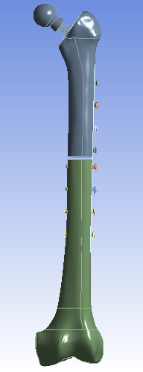

Figure 31 - CAD Model of Femur

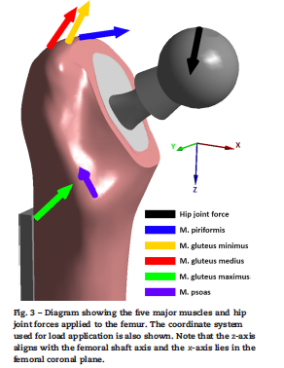

Figure 32 - Major Muscle and Hip Joint Forces Applied to Femur

Table 7 - Force Components for Muscle and Joint Reaction Forces

|  |  |  |  |
| --- | --- | --- | --- |
| Muscle Name | Force Components (N) | | |
| X | Y | Z |
| Hip Joint Force | -613.7 | -219.3 | 2868.7 |
| Piriformis | 110.5 | -70.1 | -22.4 |
| Gluteus Minimum | 25.4 | -0.7 | -51.6 |
| Gluteus Medius | 63.7 | -28.9 | -113.3 |
| Gluteus Maximus | 172.4 | -105 | -203.8 |
| Psoas | 3.6 | 160.6 | -158.5 |

### 3.5.2 Material Properties

Many materials are included in the assembly of the CAD model. From the various elastic properties of bone to the metals used in conventional plates to the composite in question, these properties are recorded in Table 8 below. The Materials that only exhibit *Ex*, *vxy*, and $σ_{XU}$ were assumed isotropic, wherease the two composite materials are orthotropic. E-Glass/Epoxy Properties were obtained from ANSYS Workbench Material Library. These values are very similar to the values that the team had measured, however, ANSYS provided a few more values that are needed in computational analysis. Therefore the decision was to use the parameters provided by ANSYS.

Table 8 - Linear Elastic Material Properties Used in computational analysis (Samiezadeh et al, 2014)

|  |  |  |  |  |  |  |
| --- | --- | --- | --- | --- | --- | --- |
| Material | *Ex*(GPa) | *Ey­* (GPa) | *Gxy* (GPa) | *vxy* | *vyx* | (MPa) |
| Flax/Epoxy | 35 | 4.4 | 2.1 | 0.3 | 0.4 | 330 |
| *EGlass/Epoxy* | 45 | 10 | 5 | 0.3 | 0.4 | 1100 |
| Ti-6Al-4V | 113.8 | - | - | 0.34 | - | 950 |
| 316L Stainless Steel | 193 | - | - | 0.3 | - | 235 |
| CoCrMo | 210 | - | - | 0.31 | - | 872 |
| Bone Cement | 2.45 | - | - | 0.38 | - | 62 |
| Callus | 0.1 | - | - | 0.35 | - | 23 |
| Cortical Bone | 16.7 | - | - | 0.26 | - | 106 |
| Trabecular Bone | 0.155 | - | - | 0.3 | - | 6 |

### 3.5.3 Finite Element Analysis

ANSYS Workbench is a software that performs finite element analysis of a model and can determine and variable in question, in our case, stress and deformation. Four configurations were selected to be analyzed using ANSYS Workbench. These configurations are C1, C2, C7, and C10. Using the ACP extension (ANSYS Composite PrepPost), the team was able to design the plate to any given configuration that can then be analyzed and a solution can be generated.

### 3.5.4 Computational Results

Workbench provided the solutions for not only stress values, but the corresponding deformation. Solutions for Plate Stress, Bone Surface Stress, Plate Deformation, and Total Deformation were obtained and recorded in Table 9.

Table 9 - Major Results Obtained Through ANSYS Workbench

|  |  |  |  |  |
| --- | --- | --- | --- | --- |
|  | Maximum Bone Surface Stress (MPa) | Maximum Plate Stress (MPa) | Maximum Total Deformation (mm) | Maximum Plate Deformation (mm) |
| C1 | 458.53 | 731.20 | 12.351 | 6.8862 |
| C2 | 582.87 | 517.78 | 12.879 | 7.1275 |
| C7 | 541.12 | 522.37 | 12.501 | 6.9338 |
| C10 | 511.34 | 555.71 | 12.512 | 6.9445 |

 (a)

 (b)

 (c)

 (d)

Figure 33 - Plate Surface Stress from configurations (a) C1 (b) C2 (c) C7 (d) C10

Analyzing the maximum stresses from Table 9, a few patterns arise. Firstly, it was known that Configuration 1 would have the highest maximum plate stress and lowest maximum bone surface stress with respect to the other configurations, due to the highest axial stiffness that is present with unidirectional composites. To reiterate, this configuration is not ideal as the goal is to prevent stress shielding. The maximum plate stress should theoretically be reduced to allow more stress absorption from the femur. There is a 272.2 MPa difference between the plate stress and bone stress that demonstrates the discrepancy in the absorption of stress. All other configurations provide a difference in absorption of stress no larger than 65.1 MPa. Once more, it is fully expected that the highest axial stiffness should provide the lowest maximum total and plate deformations. Looking at Table 9, this is the case.

Configuration 7 had been selected early on as the potential best configuration, as the previous study of Carbon Fiber/Flax/Epoxy had come to this conclusion. From analyzing the stiffness characteristics of C7, it had the lowest axial stiffness (14.98 MN) and moderate bending and torsional stiffness (19.87 and 3.10 Nm2, respectively). FEA results further develop reasoning for C7 being the optimal configuration, as C7 provides the most balanced trade-off between plate stress and bone stress (18.75 MPa).

## 3.6 Testing of E-Glass/Flax/Epoxy Prototype

A square “plate” 15 inch by 15 inch was manufactured and consisted of symmetric 20 layers of E-Glass/Flax/Epoxy with the configuration [02/+45/02/45/902]s. The specimens were then manually cut from the base “plate” using a diamond tooth circular saw to comprise of a rectangular profile, tensile specimens were shaped to be 10 inches by 0.9 inches and bending samples were shaped to be 11 inches by 0.5 inch.

The reason justification for the tensile specimen’s dimensions were based on the D3039 ASTM standards for “Tensile Properties of Polymer Matrix Composite Materials”, which recommend that samples be 1inch wide and 10 inches long (ASTM, 2014). Due to human error when cutting the samples the desired width was not obtained. In addition the reason the justification for the bending sample dimension were based on the D7264 ASTM standards for “Flexural Properties of Polymer Matrix Composite Materials”, which recommends that samples be 0.5 inches wide, however there is no definitive length for the sample (ASTM, 2015). There is a recommend span-to-thickness ratio, but when the team realized this the samples were already used.

### 3.6.1 Tension Test Results

The results obtained from the tensile test show consistent results with all five specimens (Table 10). The modulus of the composite material ranged from 15.033 GPa to 21.939 GPa. Taking the average of the results exhibited modulus of 18.474 GPa, while standard deviation of the obtained data equated 2.489 GPa. Figure 34 shows the Stress-Strain curve of the 5 specimens, the graph was created by calculating the stress from the attained puling force data and using the strain data gathered using an extensometer. Figure 34 of the tensile test result represents the linear (elastic) portion of the curve, results beyond the elastic region were not considered because the extensometer had to be removed thus unable to record the strain. Analysis of Figure #34 shows mostly linear positive sloping lines with minor deflection, therefore the composite material predominantly behaved elastically during testing. Material failure for all five specimens occurred after the elastic tension phase and the composite fractures cleanly (i.e. the specimen severed into two sections through and through).

Figure 34 - Elastic (Linear) Portion of the Stress-Strain Curve of E-Glass/Epoxy/Flax Composite Acquired By Conducting Tensile Tests On Five Specimens

Table 10 - Tensile Test Attained Properties of Specimens of E-Glass/Epoxy/Flax Composite

|  |  |  |  |
| --- | --- | --- | --- |
| Specimen ID | Tensile Strength (N) | Tensile Strength (GPa) | Modulus (GPa) |
| TTS-001L | 2,875 | 0.281 | 19.202 |
| TTS-002L | 3,380 | 0.301 | 21.939 |
| TTS-004L | 3,156 | 0.256 | 15.033 |
| TTS-005L | 2,908 | 0.237 | 18.347 |
| TTS-006L | 3,379 | 0.283 | 17.852 |
| MEAN | 3,140 | 0.271 | 18.474 |
| Std. Dev | 244 | 0.025 | 2.489 |

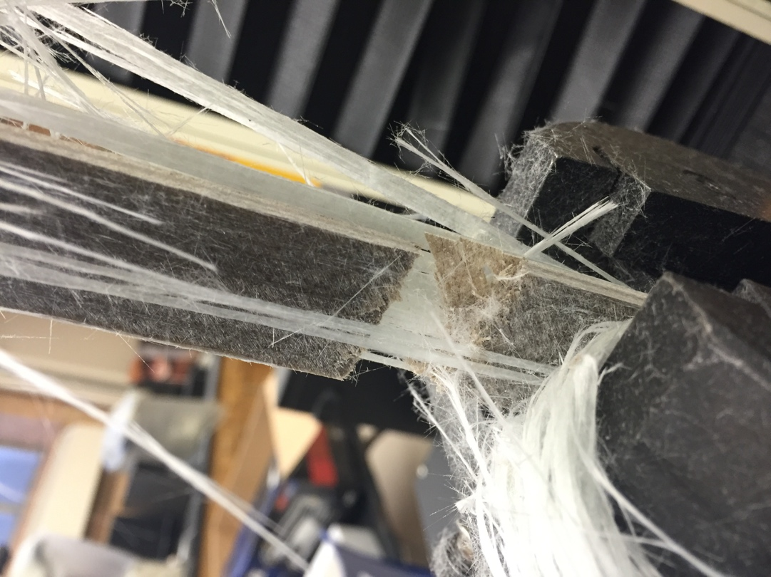

Figure 35 - Specimen After Point Of Fracture Severed Into 2 Fragments

All five specimens exhibited very similar fracture phenomena; fracturing for the E-Glass fiber/Epoxy/flax fiber composite occurred slowly. In all five samples fracturing began with the delamination of the E-Glass fibers from the Flax/Epoxy layers, as the material was subjected to further tension, individual E-Glass fibers started to split into two segments at various locations along the length of the specimen, as seen in Figure 35.

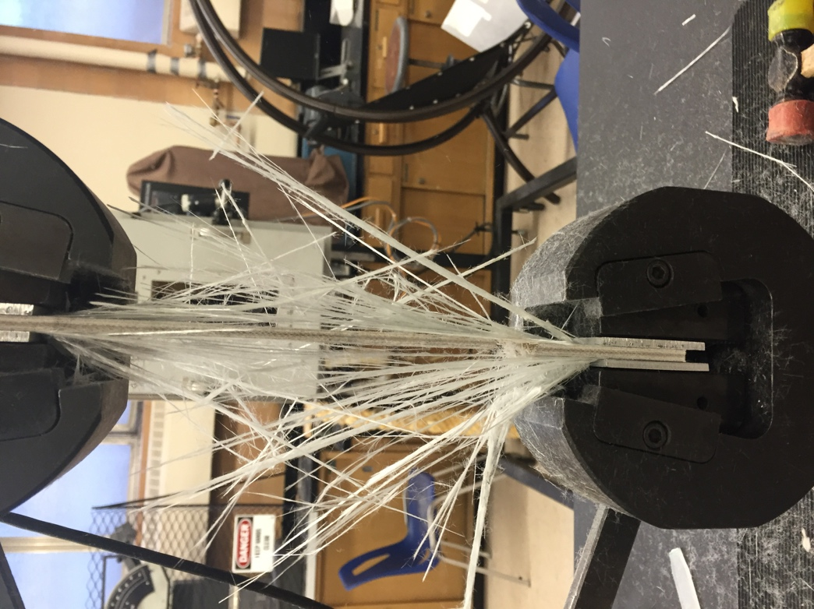

Figure 36 - E-Glass Fibers splitting after failure

The location where the E-Glass split was most likely determined as the location of weakest point long the length of individual fibers as, this is due to microscopic fiber imperfections. The location of imperfections makes the fiber more prone to failure. Once most of the glass fibers had split from both ends of the specimen, with enough tension applied the flax/epoxy combination snapped spontaneously into two fragments. This behavior was repetitively observed in all specimens.

Although the results are consistent they have a slight deviation which could have been a result of specimen aberration. All specimens varied in size because they were manually cut with a circular saw. Hence the cross section of the specimens varies slightly not only from one specimen to the next but also within the specimens. This could have resulted in the variation in the results. Furthermore, the E-Glass/Flax/Epoxy fiber composite could have had a variance in material properties within the material due to manufacturing. Lastly experimental error such as measuring limitations and although tabs were used during the experiment, minor specimen slippage could have contributed to variance on results. Overall however, the results were very consistent.

### 3.6.2 Bending Test Results

The bending test results attained were constant much like the tensile tests. The modulus of the E-Glass/Flax/Epoxy composite material ranged from 258MPa to 267 MPa (shown in Table 11). The calculated mean modulus equated 263 MPa, while the standard deviation was 4 MPa. The deviation is very minimal (1.5% of the mean), thus the results are very accurate. As seen in Figure 37 the result of the test exhibited a linear positive sloping line during the elastic region with insignificant variance from complete linearity. The region of Figure 37 subsequent to the linear region exhibits fracture within the specimen.

The fracture phenomena with all five specimens were very alike. Fracturing began in the E-glass fibers facing upwards (i.e. towards the load) at the site of contact with the loading pin. Next, the E-Glass layers on the opposite side of the loading pin began to fracture on the same line as the loading pin. As the load was increased non E-Glass supported layers of Flax/Epoxy began to break into 2 fragments at the site of contact with the loading pin as well as seen in Figure 38. Several of the Flax/epoxy layers fail at simultaneously but not all together at once. This is contradictory to the flax/epoxy failure during tensile test where the entire Flax/Epoxy section failed at once the tension surpassed the threshold. This can be seen clearly in Figure 37, the figure shows sudden declining spikes on the graph after the linear region. As the load was increased several layers at a time of Flax/Epoxy snapped spontaneously showing the decline on the graph. This process repeated until all the Flax/Epoxy layers had failed. The E-Glass Layers snapped into 2 parts once enough force was applied, first on top then on the bottom.

Figure 37 - Force-Deflection Curve of E-Glass/Epoxy/Flax Composite Acquired By Conducting Three-Point Bending Tests on 5 Specimens with Fibers Running in the Longitudinal Direction

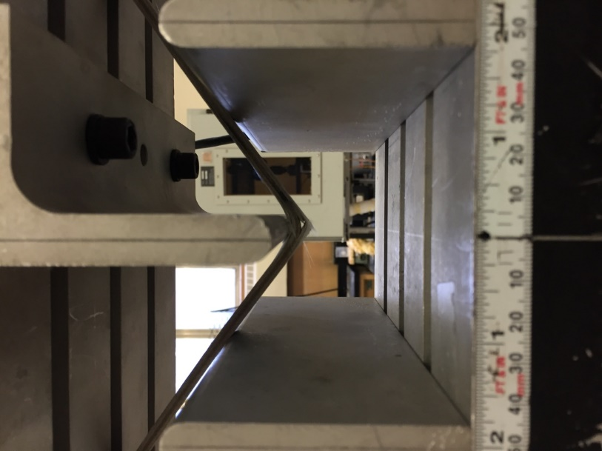

Figure 38 - Test Specimen After All Layers Have Failure

Table 11 - Properties Collected From Conducting Bending Test of Specimens of E-Glass/Epoxy/Flax Composite Running In The Longitudinal Direction

|  |  |  |  |
| --- | --- | --- | --- |
| Specimen ID | Tensile Strength (N) | Tensile Strength (MPa) | Modulus (MPa) |
| BTS-001L | 991 | 14.54 | 261 |
| BTS-002L | 712 | 11.6 | 258 |
| BTS-003L | 1,302 | 19.66 | 267 |
| BTS-004L | 865 | 14.13 | 264 |
| MEAN | 968 | 15 | 263 |
| Std. Dev | 250.49 | 3 | 4 |

In addition bending tests were performed on samples that had the fibers orientated in the transverse direction. By performing the test the team was able to examine how the bending stiffness varies based on the orientation of the plies within the laminate. The material behaviour between the two samples is very similar as seen in Figure 39. Furthermore the results for the modulus are very close, with an average value of 36.5 MPa and a standard deviation of only 3.54. Based on the average value of the modulus in Table 11, the modulus for the longitudinal samples is approximately 8 times larger than the transverse samples. As a result in order to have a stronger bending stiffness the outer layers should be orientated at 0° instead of 90°.

Figure 39 - Force-Deflection Curve Of E-Glass/Epoxy/Flax Composite Acquired by Conducting Three-Point Bending Tests on Five Specimens with Fibers Running Transverse Direction

Table 12 - Properties Collected From Conducting Bending Test of Specimens of E-Glass/Epoxy/Flax Composite Running in the Transverse Direction

|  |  |  |  |
| --- | --- | --- | --- |
| Specimen ID | Tensile Strength (N) | Tensile Strength (MPa) | Modulus (MPa) |
| BT-001T | 141 | 2.72 | 34 |
| BT-002T | 157 | 2.98 | 39 |
| MEAN | 149 | 2.850 | 36.50 |
| Std. Dev | 11.31 | 0.184 | 3.54 |

# CHAPTER 4 – DISCUSSION & CONCLUSION

## 4.1 Comparison with existing designs

### 4.1.1 Contemporary Metals (Stainless Steel, Titanium), and Bone

Now that the material properties of the E-Glass/Flax/Epoxy laminate have been determined, it can be compared to common materials that are being used for bone plates. The values for some of those common materials are listed in the table in Figure 40. From that table it shows that the Young’s modulus of; Ti–6AL–4V is 113 GPa, 316L Stainless steel is 193 GPa, and Cortical bone is 16.7 GPa. Since the objective of this study was to find a material that has a stiffness close to the human bone and the bone plate has a modulus of 18.474 GPa, it seems the material may be effective at reducing stress shielding.

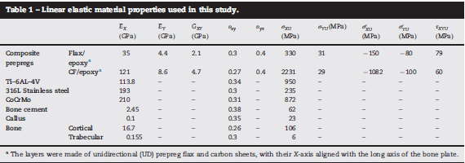

Figure 40 - Table of Linear Elastic Material Properties (Samiezadeh et al., 2015)

### 4.1.2 Carbon-Fiber/Flax/Epoxy

The Carbon Fiber/Flax/Epoxy composite had been considered as a measuring stick from the onset of this project. The goal for the team was to ultimately design a product that theoretically and experimentally provides a superior option to that of Carbon Fiber. Table 13 outlines the results gathered by the previous study. That study concluded that C7 had in fact been the optimal configuration. Therefore, there will be a direct comparison between C7 for Carbon Fiber and C7 for Glass Fiber.

Table 13 - Carbon-Fiber/Flax/Epoxy Stiffness Results from Previous Study (Samiezadeh et al, 2014)

|  |  |  |  |  |
| --- | --- | --- | --- | --- |
| Configuration | Stacking Sequence | EA (MN) | EI (Nm2) | GJ (Nm2) |
| C1 | [0C/08F]s | 2.7 | 4.0 | 0.76 |
| C2 | [452/45/0/-45/0/45/0/-45/903]s | 4.2 | 8.1 | 27.1 |
| C6 | [45/02/+452/0/45/903]s | 4.2 | 12.1 | 23.1 |
| C7 | [45/02/45/0/-452/452/-45/903]s | 4.2 | 13.3 | 21.8 |
| C8 | [45/02/45/0/-452/45/0/904]s | 4.8 | 14.0 | 20.9 |
| C9 | [45/02/45/02/-452/45/904]s | 4.8 | 15.1 | 19.8 |
| C10 | [45/04/+452/904]s | 4.8 | 16.0 | 18.9 |

In general, the stiffness values for Carbon Fiber/Flax/Epoxy are considerably higher than those of E-Glass/Flax/Epoxy. For comparison, both optimal configurations (C7) will be analyzed. From Table 5 previously, E-Glass composite yielded the following stiffnesses: Axial Stiffness (EA) = 1.4269 MN, Bending Stiffness (EI) = 4.9432 Nm2, and Torsional Stiffness (GJ) = 7.8948 Nm2. In a direct comparison, Carbon Fiber yields an Axial Stiffness of almost 3 times greater, a Bending Stiffness of 2.7 times greater, and a torsional stiffness of 2.75 times greater than E-Glass. This result was very much expected, and further analysis through ANSYS simulation will help further examine the stresses and deformation that occurs in both designs.

In Table 14 below, we recall the major results obtained for C7 E-Glass/Flax/Epoxy plate, and include the major results for C7 Carbon Fiber/Flax/Epoxy plate (denoted as CF). The values are very similar in terms of Maximum Bone Surface Stress. However, for Carbon Fiber, the plate absorbs almost 300 MPa more stress and also deforms less than the E-Glass. This is very interesting, but favours the E-Glass plate since much less stress is placed on the plate while maintaining an almost equivalent bone surface stress. Not to mention that there is an evenly distributed stress between Bone surface and plate. This result is very exciting, as the goal of this project was to theoretically reduce the stiffness in a plate to promote the distribution of stress.

Table 14 - Major Results Obtained Through ANSYS Workbench for E-Glass & Carbon Fiber

|  |  |  |  |  |
| --- | --- | --- | --- | --- |
|  | Maximum Bone Surface Stress (MPa) | Maximum Plate Stress (MPa) | Maximum Total Deformation (mm) | Maximum Plate Deformation (mm) |
| C7 | 541.12 | 522.37 | 12.501 | 6.9338 |
| CF C7 | 561.39 | 825.85 | 10.514 | 5.8282 |

## 4.2 Conclusion

This study has evaluated the material properties of an E-Glass/Flax/Epoxy composite. The study has found that the composite material has a lower axial, bending, and torsional stiffness than the reference design (the CF/Flax/Epoxy). These results support the claim that the composite has similar mechanical properties of the human bone. This means it could be considered as a candidate for bone plates due to its ability to reduce stress shielding. The requirements to design, optimize and manufacture the bone plate were all completed. The team used theoretical values, simulation results and experimental data to verify each of the results to confirm if it was accurate and precise. It was found that the calculations for axial stiffness were quite accurate and that the Young’s modulus was fairly close (14.1407 GPa for theoretical, and 18.474 GPa). Even though the manufactured design wasn’t the optimized configuration it is hypothesized that because of the positive results for the experimental data, that the optimal design will also yield positive results in experimental trials. However the calculations for the flexural modulus were incorrect, the accuracy of the results was far apart. The reason for this error is most likely due to assumption made during the theoretical calculation process. But the experimental results were very similar so it is unlikely the experimental results are inaccurate. Also by using ANSYS Workbench the team was able to simulate the results of the reference design versus the new design to compare the stresses and deformation. From the simulations it was found that the new design had lower stresses but higher deformation. Therefore there are still some flaws that will need to be looked into before using this material in bone plates.

The group did have minor setback throughout the duration of the project. These obstacles include; confusion about what needed to be done and how to solve certain problems, obtaining the necessary materials and apparatus. One specific example was that initially the project requirement was for the team to perform compression and torsion tests, but because the testing apparatus was not available for the team to use, the scope of the project had to be reduced. Although the team had many challenges, the majority of the project yielded positive results, and was able to verify the objective of the project, which is to determine is E-Glass/Flax/Epoxy would be a viable candidate for bone plates.

## 4.3 Recommendations

Although the study was completed there are other areas to research to verify if this material would be a suitable candidate for bone plates. During the study both compression tests and torsion tests were excluded because the team wasn’t able to access the machinery to run the test. These tests would be beneficial for further research to examine the material behavior when undergoing compression and torsional forces. Another recommendation is to determine how cyclic loading affects the stiffness of the bone plate, because the bone plate is normally designed for a long life cycle. Also fatigue/endurance limits should also be looked into to determine how much stress the composite can withstand before failure, or if it can last an infinite life-time.

Other authors have suggested other areas of interest to research as well. One example would be to determine the required axial and torsional stiffness, if these values are found it would be very beneficial as it gives more design requirements making the design process much more focused, instead of leaving open-ended assumptions. Also the assumption of comparing laminate theory to beam theory may have to be looked over, since the results from this study did not match the experimental results. It is also recommended to follow the engineering standards more precisely in order to have the work be credible and compared to other future designs.

To further increase the potential application of the E-Glass/Epoxy/ Flax fiber composite, future studies on the composite’s water absorbability should be performed. Though natural fibers are low density, and have good biocompatibility, they suffer from being hydrophilic. This hydrophilic characteristic leads to high moisture absorbance, which results in the weakening of the fiber’s properties and overall degradation of the fiber- matrix interface. Potential solutions for this problem could be the development of a hydrophilic coating for the composite material that would repel water from the bone plate, thus providing protection for the Flax fibers inside. The improvement of the flax fibers’ integration with the epoxy matrix could also be further improved to provide a stronger composite with less possibility for voids and defects. Future lines of testing could involve the use of a variety of different epoxy resins or new compression molding techniques.

# REFERENCES

Agarwal, B., Broutman, L., & Chandrashekhara, K. (2006). Analysis and performance of fiber composites. Hoboken, N.J.: John Wiley.

Albrektsson, T. & Johansson, C. (2001) Osteoinduction, osteoconduction and osseointegration. European Spine Journal 10: 96–101.

Aro, H.T., Chao, E.Y., 1993. Bone-healing patterns affected by loading, fracture fragment stability, fracture type, and fracture site compression. Clin. Orthop. Relat. Res. 293, 8–17.

ASTM, D3039/D3039M—14. Standard Test Method for Tensile Properties of Polymer Matrix Composite Materials. West Conshohocken, PA: ASTM International, 2014; pp.1–13.

ASTM, D4762—11a. Standard Guide for Testing Polymer Matrix Composite Materials. West Conshohocken, PA: ASTM International, 2011; pp.1–21.

ASTM, D5467/D5467M—10. Standard Test Method for Compressive Properties of Unidirectional Polymer Matrix Composite Materials Using a Sandwich Beam. West Conshohocken, PA: ASTM International, 2010; pp.1–10.

ASTM, D6641/D6641M—14. Standard Test Method for Compressive Properties of Polymer Matrix Composite Materials Using a Combined Loading Compression (CLC) Test Fixture. West Conshohocken, PA: ASTM International, 2014; pp.1–13.

ASTM, D7264/D7264M—15. Standard Test Method for Flexural Properties of Polymer Matrix Composite Materials. West Conshohocken, PA: ASTM International, 2015; pp.1–10.

Augat, P., Burger, J., Schorlemmer, S., Henke, T., Peraus, M., Claes, L., 2003. Shear movement at the fracture site delays healing in a diaphyseal fracture model. J. Orthop. Res. 21 (6), 1011–1017.

Augat, P., Simon, U., Liedert, A., & Clacs, L. (2004, September 15). Mechanics and machano-biology of fracture healing in normal and osteoporotic bone. *Osteoporosis International, 16*(S02), S36-S43. doi:10.1007/s00198-004-1728-9

Bagheri, Z., El Sawi, I., Schemitsch, E., Zdero, R., & Bougherara, H. (2013). Biomechanical properties of an advanced new carbon/flax/epoxy composite material for bone plate applications. *Journal Of The Mechanical Behavior Of Biomedical Materials*, *20*, 398-406. http://dx.doi.org/10.1016/j.jmbbm.2012.12.013

Ballo, A., Akca, E., Ozen, T., Lassila, L., Vallittu, P., & Närhi, T. (2009). Bone tissue responses to glass fiber-reinforced composite implants - a histomorphometric study. *Clinical Oral Implants Research*. http://dx.doi.org/10.1111/j.1600-0501.2008.01700.x

Bartel, D.L., Davy, D.T., Keaveny, T.M., 2006. Orthopaedic Biomechanics: Mechanics and Design in Musculoskeletal Systems. Pearson/Prentice Hall.

Barwick,, J., & Nowotarski, P. (2011). *Femur Shaft Fractures (Broken Thighbone)-OrthoInfo - AAOS*. *Orthoinfo.aaos.org*. Retrieved 18 February 2016, from http://orthoinfo.aaos.org/topic.cfm?topic=A00521

Benli, Semih, Sami Aksoy, Hasan Havıtcıoğlu, and Mumin Kucuk. "Evaluation of Bone Plate with Low-stiffness Material in Terms of Stress Distribution." *Journal of Biomechanics* 41.15 (2008): 3229-235. Web. 25 Feb. 2016.

Callister, W., & Rethwisch, D. (2012). Fundamentals of Materials Science and Engineering - An Integrated Approach (4th Edition). Hoboken, NJ: John Wiley & Sons.

Callister, W., & Rethwisch, D. (2014). Materials Science and Engineering - An Introduction (9th ed.). John Wiley & Sons, Inc.

Cheal, E. J., Spector, M., & Hayes, W. C. (1992). Role of Loads and Prosthesis Material Properties on the Mechanics of the Proximal Femur after Total Hip Arthroplasty. *Journal of Orthopsedic Research, 10*(3), 405-422. Retrieved February 17, 2016, from http://journals1.scholarsportal.info.ezproxy.lib.ryerson.ca/pdf/07360266/v10i0003/405_rolapmpfatha.xml

Clyne, B. (2000). Composite Materials. Matter.org.uk. Retrieved 26 February 2016, from http://www.matter.org.uk/matscicdrom/manual/co.html

Comprehensive online reference in daily clinical life. (n.d.). Retrieved April 08, 2016, from https://www2.aofoundation.org/wps/portal/!ut/p/a0/04_Sj9CPykssy0xPLMnMz0vMAfGjzOKN_A0M3D2DDbz9_UMMDRyDXQ3dw9wMDAx8jfULsh0VAdAsNSU!/?BackMode=true

Duda, G. N., Schneider , E., & Chao, E. Y. (1997, December 12). Internal Forces And Moments In The Femur During Walking. *Journal of Biomechanics, 30*(9), 933-941. Retrieved February 16, 2016, from http://www.sciencedirect.com.ezproxy.lib.ryerson.ca/science/article/pii/S0021929097000572

Duncan, C. P., Toms, A., & Masri, B. A. (2006). Minimally Invasive or Limited Incision Hip Replacement: Carification and Classification. *AAOS Instructional Course Lectures, 55*, 195-197.

Efunda.com,. (2016). eFunda: Estimanation of Lamina Material Constants. 14 February 2016, from http://www.efunda.com/formulae/solid_mechanics/composites/calc_ufrp_EGNu.cfm

Efunda.com,. (2016). eFunda: Lamina Stress-Strain Relations for Principal Directions. Retrieved 14 February 2016, from http://www.efunda.com/formulae/solid_mechanics/composites/comp_lamina_principal.cfm

Efunda.com,. (2016). eFunda: Classical Lamination Theory. Retrieved 13 February 2016, from http://www.efunda.com/formulae/solid_mechanics/composites/comp_laminate.cfm

eFunda: Stress-Strain Relations of Materials. (2016). Efunda.com. Retrieved 13 February 2016, from http://www.efunda.com/formulae/solid_mechanics/composites/comp_lamina_property.cfm

Han, Na, Ifty Ahmed, Andrew J. Parsons, Lee Harper, Colin A. Scotchford, Brigitte E. Scammell, and Chris D. Rudd. "Influence of Screw Holes and Gamma Sterilization on Properties of Phosphate Glass Fiber-reinforced Composite Bone Plates." *Journal of Biomaterials Applications* 27.8 (2013;2011;): 990-1002. Web. 25 Feb. 2016.

Histing, Tina, Patric Garcia, Romano Matthys, Markus Leidinger, Joerg H. Holstein, Alexander Kristen, Tim Pohlemann, and Michael D. Menger. "An Internal Locking Plate to Study Intramembranous Bone Healing in a Mouse Femur Fracture Model." *Journal of Orthopaedic Research : Official Publication of the Orthopaedic Research Society* 28.3 (2010;2009;): 397-N/a. Web. 25 Feb. 2016.

Huang, Zheng-Ming, and K. Fujihara. "Stiffness and Strength Design of Composite Bone Plates." *Composites Science and Technology* 65.1 (2005): 73-85. Web. 25 Feb. 2016.

Kassapoglou, D. (2016). Advanced Design and Optimization of Composite Structures I: Classical Laminate Theory (CLT). Ocw.tudelft.nl. Retrieved 13 February 2016, from http://ocw.tudelft.nl/courses/master-aerospace-engineering/advanced-design-and-optimization-of-composite-structures-i/lectures/classical-laminate-theory-clt/

Kim, S.-H., Chang, S.-H., Jung, H.-J., (2010). The finite element analysis of a fractured tibia applied by composite bone plates considering contact conditions and time-varying properties of curing tissues. Compos. Struct. 92 (9), 2109–2118.

Kollar, L., & Springer, G. (2003). Mechanics of composite structures. Cambridge: Cambridge University Press.

Lassila, L.V., Nohrstrom, T. & Vallittu, P.K. (2002) The influence of short-term water storage on the flexural properties of unidirectional glass fiberreinforced composites. Biomaterials 23: 2221– 2229.

Maharaj, P. S. R. Senthil, R. Maheswaran, and A. Vasanthanathan. "Numerical Analysis of Fractured Femur Bone with Prosthetic Bone Plates." *Procedia Engineering* 64 (2013): 1242-251. Web. 25 Feb. 2016.

Malleable or reconstruction plate fixating a femoral [Digital image]. (2012, November 25). Retrieved February 10, 2016, from http://www.raddaily.com/whitepaperarticle.php?articleTitle=Orthopedic Hardware

Paschoal, F., & Paccola, C. (2000). *Classification of Diasphyseal Femoral Fractures according to the AO Classification*. Retrieved from http://www.scielo.br/scielo.php?pid=S1413-78522000000400002&script=sci_arttext&tlng=en

Rockwood, C.A., Bucholz, R.W., Green, D.P., Court-Brown, C.M., Heckman, J.D., Tornetta, P., 2010. Rockwood and Green’s Fractures in Adults. Wolters Kluwer Health/Lippincott Williams & Wilkins, Philadelphia.

Samiezadeh, S., Avval, P.T., Fawaz, Z., & Bougherara, H., (2015). On optimization of a composite bone plate using the selective stress shielding approach. J. Mech. Behav. Biomed. Mater. 42. 138–153.

SMA/MEMS Research Group. "Bone Plates." *Bone Plates*. University of Alberta, n.d. Web. 25 Feb. 2016.

Soballe, K., Gotfredsen, K., Brockstedt-Rasmussen, H., Nielsen, P.T. & Rechnagel, K. (1991) Histologic analysis of a retrieved Hydroxyapatite coated femoral prosthesis. Clinical Orthopaedics & Related Research 272: 255–258.

Son, Dae-Sung, and Seung-Hwan Chang. "The Simulation of Bone Healing Process of Fractured Tibia Applied with Composite Bone Plates According to the Diaphyseal Oblique Angle and Plate Modulus." *Composites Part B: Engineering* 45.1 (2013): 1325-335. Web. 25 Feb. 2016.

Väkiparta, M., Koskinen, M., Vallittu, P., Närhi, T., & Yli-Urpo, A. (2004). In vitro cytotoxicity of E-glass fiber weave preimpregnated with novel biopolymer. *Journal Of Materials Science: Materials In Medicine*, *15*(1), 69-72. http://dx.doi.org/10.1023/b:jmsm.0000010099.58361.1b

Vallittu, P.K. (1999) Flexural properties of acrylic resin polymers reinforced with unidirectional and woven glass fibers. Journal of Prosthetic Dentistry 81: 318–326

Woo, S.L., Lothringer, K.S., Akeson, W.H., Coutts, R.D., Woo, Y.K., Simon, B.R., Gomez, M.A., (1984). Less rigid internal fixation plates: historical perspectives and new concepts. J. Orthop. Res. 1 (4), 431–449.

# APPENDIX A - Miscellaneous Information

A1 Muscle and Joint Contact Loads for Gait and Extreme Loading Conditions (Cheal, Spector, & Hayes, 1992)

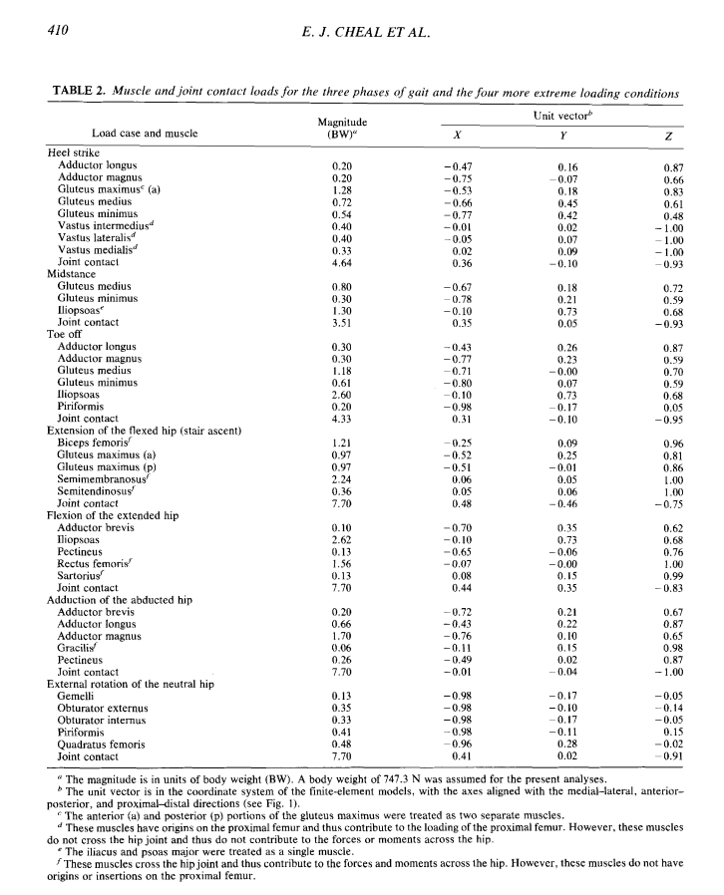

# APPENDIX B – E-Glass/Epoxy Plate Manufacturing Process Flow Chart

The following Flow Chart outlines the manufacturing process that the team had performed to create a glass fiber/epoxy composite plate. The chart lays out the individual steps taken to construct a 16 layer sheet of glass fibers running unidirectional (0°). The numbers on the flowchart correspond to side sub processes required to make the glass fiber sheet. When the sub process number is called upon in the main flow chart, it signifies when it should be completed in reference to the entire manufacturing process.

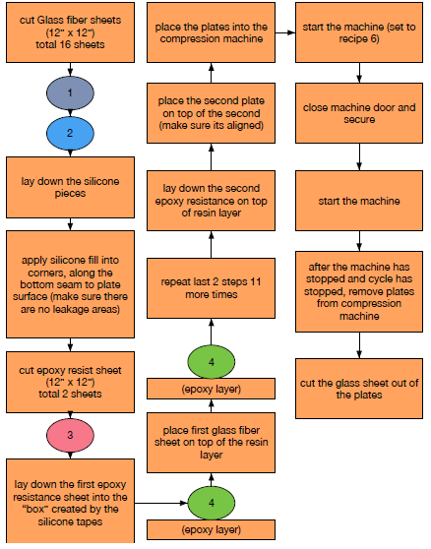

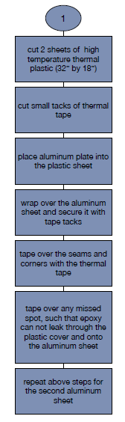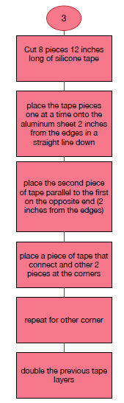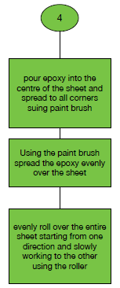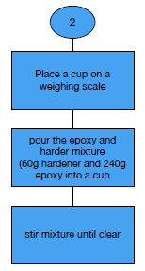

# APPENDIX C - Glass Fiber Post-Tensile-Testing

The following images are results of a few test samples of glass fiber specimens that the team conducted. These specimens were loaded in tension test machine, and the images show the fractures that occurred. The team tested 4 longitudinal fiber direction samples and 3 transverse fiber direction samples. The team will analyze the data collected to obtain mechanical properties of glass fiber. The next step would be to design the final product, which is a combination of Glass fiber and Flax. The group decided to include these images to display the current status of the project. It should be noted that only specific images were shown to avoid repetitive images, and displayed a range of different views.

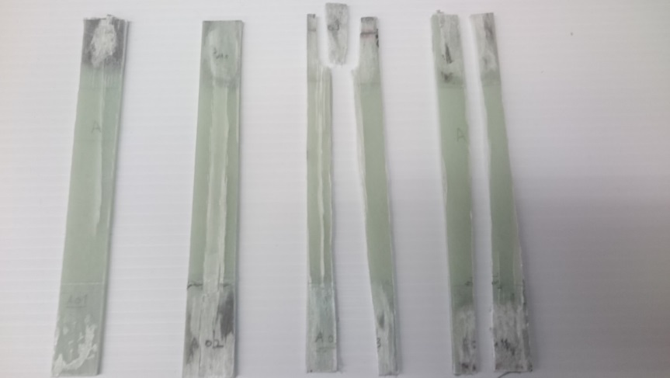

Figure 41 - Glass Fiber Specimens After Tensile Tests

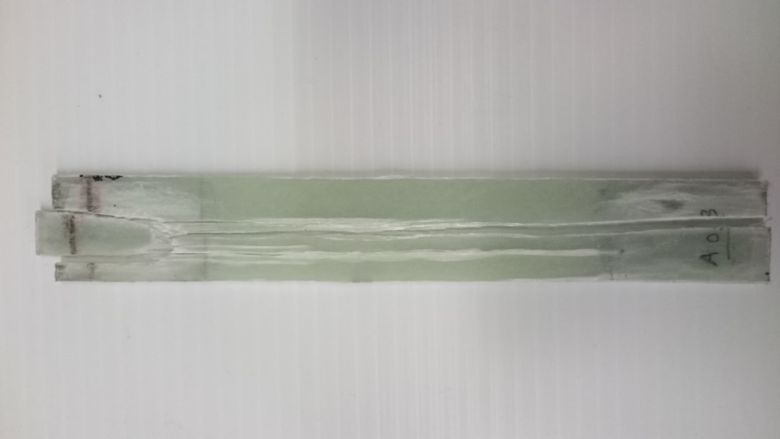

Figure 42 - Fracture of Specimen A03

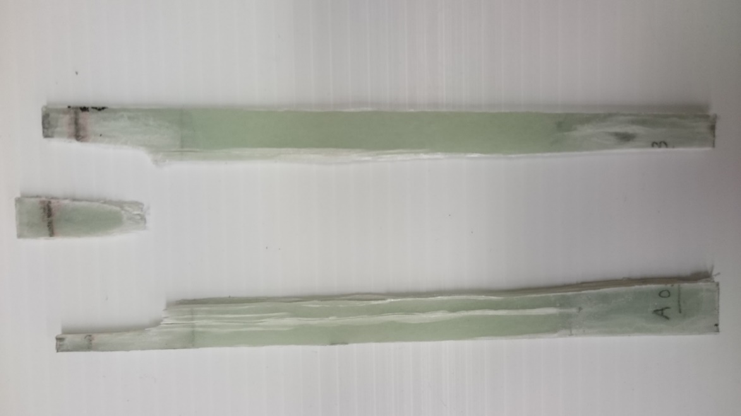

Figure 43 - Exploded View of Specimen A03

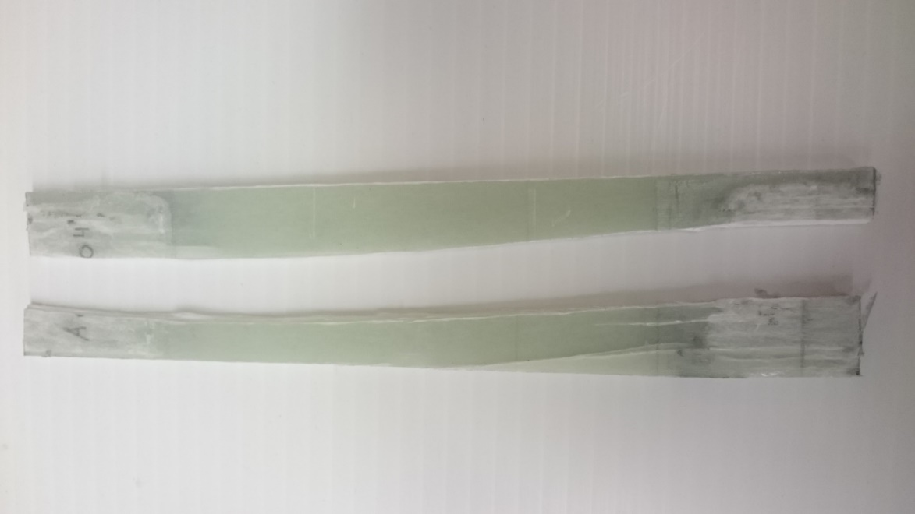

Figure 44 - Exploded View Of Specimen A04

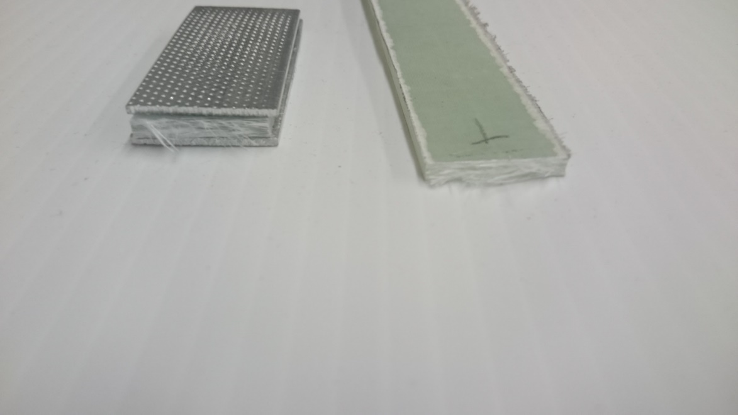

Figure 45 - Cross Section View Of Specimen At Fracture Point

# APPENDIX D - Detailed Drawings

This section provides the reader with a visual representation of the project that Adamant Technologies is currently undertaking. This project required the group to model a bone plate that is made of composite hybrid using Glass Fiber and Flax. The following drawings include both the bone plate that is under investigation as well as the long bone (femur) that the bone plate will be attached to. There is also an inclusion of a post-hip stem surgery femur, since the bone plate will mostly be used in situations where the patient had previously received a hip stem replacement. It should be noted that the following models were from a previous project with similar deliverables. With the permission of our supervisor Dr. Habiba Bougherara, Adamant Technologies would use the models to generate new configurations by inputting new parameters using ANSYS Workbench.

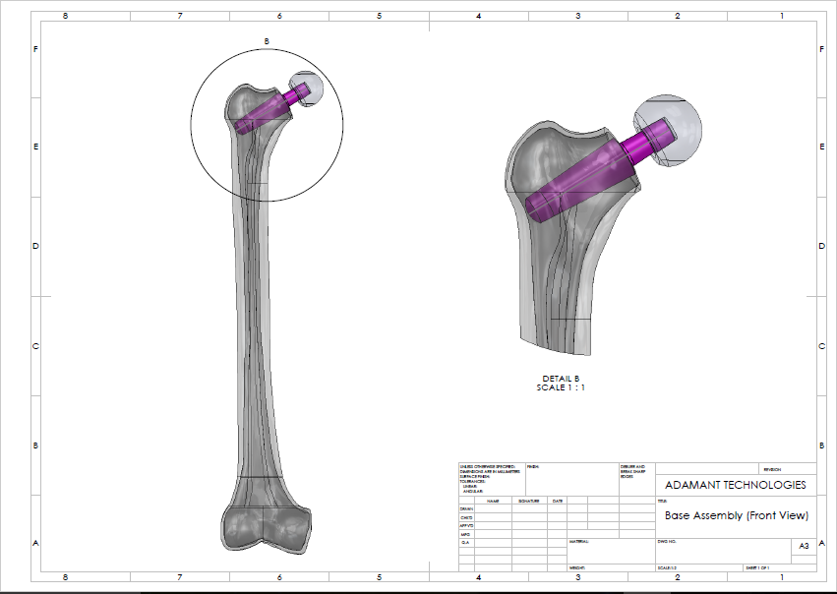

Figure 46 - Base Assembly Design Drawing

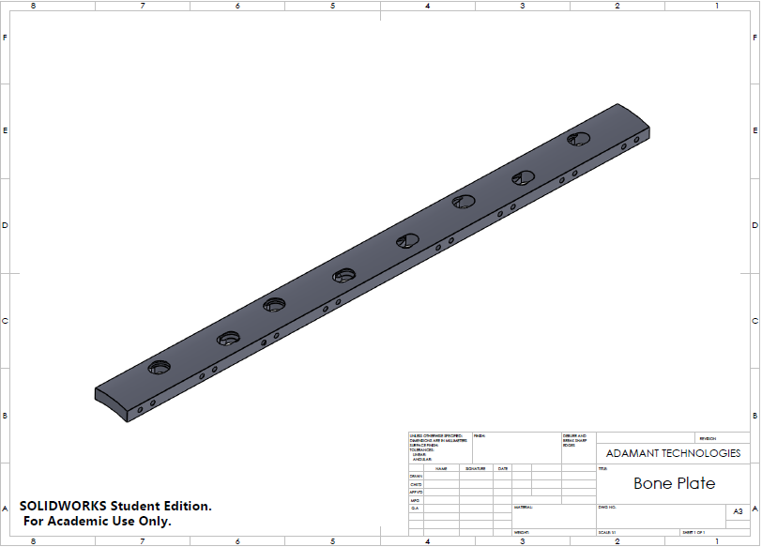

Figure 47 - Bone Plate Design Drawing

# APPENDIX E - ANSYS Workbench Results for Select Configurations

Configuration 1

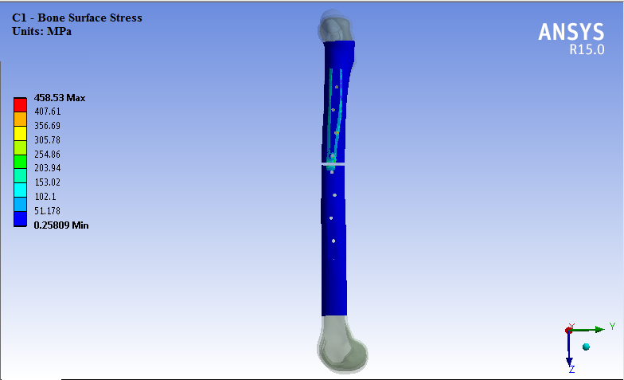

Figure 48 - Bone Surface Stress Simulation Solution for C1

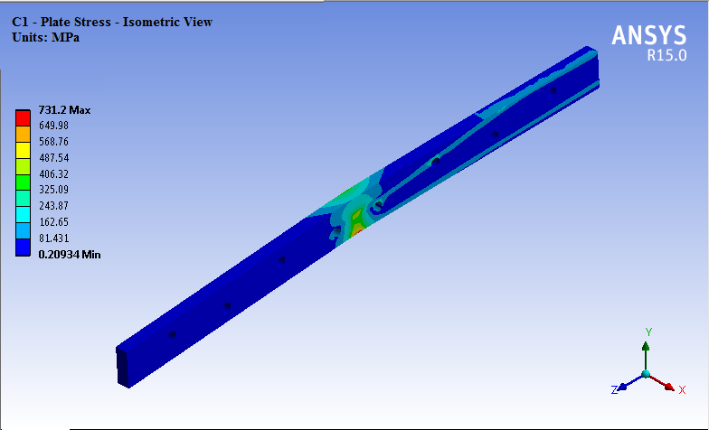

Figure 49 - Plate Stress Simulation Solution for C1

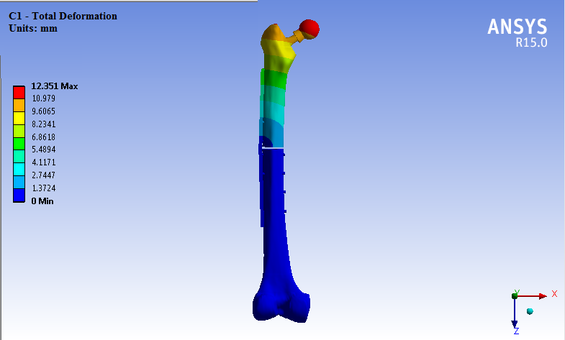

Figure 50 - Total Deformation Simulation Solution for C1

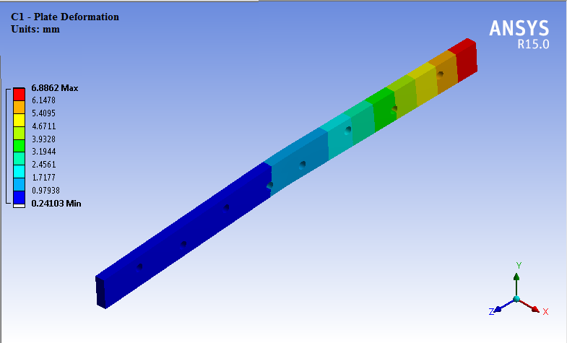

Figure 51 - Plate Deformation Simulation Solution for C1

Configuration 7

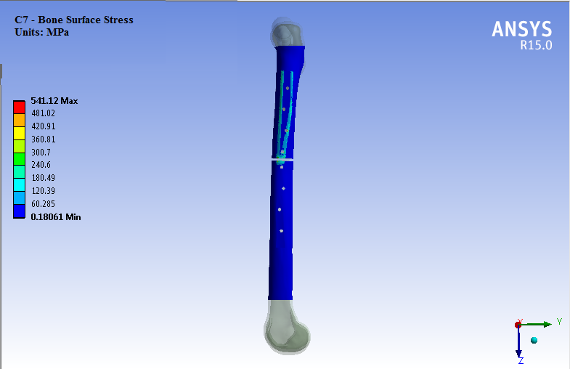

Figure 52 - Bone Surface Stress Simulation Solution for C7

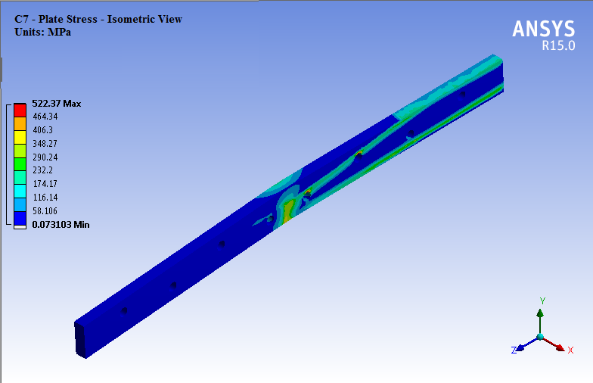

Figure 53 - Plate Stress Simulation Solution for C7



Figure 54 - Total Deformation Simulation Solution for C7



Figure 55 - Plate Deformation Simulation Solution for C7

# APPENDIX F - MATLAB Matrix Calculation for Stiffness

MATLAB code to calculate stiffness in a laminate by Sanjiv Mohanraj

*Stiffness Matrices based on C1 configuration, values obtained using eFunda

A = [206.7 8.857 0; 8.857 29.52 0; 0 0 14.08] % Extensional Stiffness Matrix  
B = [0 0 0; 0 0 0; 0 0 0]; % Coupling Stiffness Matrix  
D = [575.1 28.89 0; 28.89 96.31 0; 0 0 46.45] % Bending Stiffness Matrix  
  
a = A^-1 + A^-1*B*(D-B*(A^-1)*B)^-1*B*A^-1 % Inverse of A matrix  
d = (D-B*(A^-1)*B)^-1 % Inverse of D matrix  
  
t = 0.01697; % Width of laminate  
EA = t/a(1,1) % Axial Stiffness  
EI = t/d(1,1) % Bending Stiffness  
GJ = (4*t)/d(3,3) % Torsional Stiffness

A =  
 206.7000 8.8570 0  
 8.8570 29.5200 0  
 0 0 14.0800  
  
D =  
 575.1000 28.8900 0  
 28.8900 96.3100 0  
 0 0 46.4500  
  
a =  
 0.0049 -0.0015 0  
 -0.0015 0.0343 0  
 0 0 0.0710  
  
d =  
 0.0018 -0.0005 0  
 -0.0005 0.0105 0  
 0 0 0.0215  
  
EA = 3.4626  
  
  
EI = 9.6124  
  
  
GJ = 3.1530

[*Published with MATLAB® R2015a*](http://www.mathworks.com/products/matlab)

# APPENDIX G – E-Glass/Flax/Epoxy Composite Post-Tensile-Testing

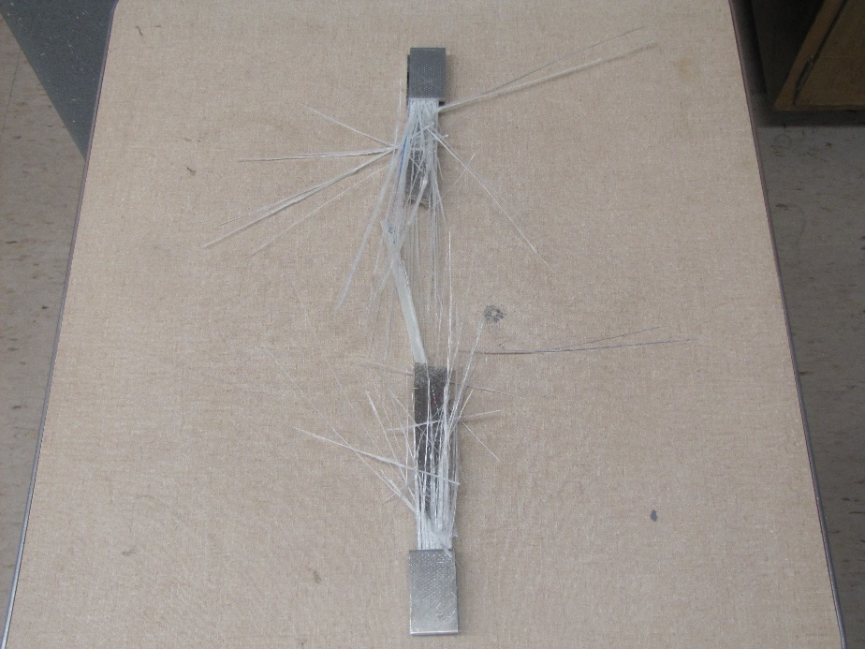

Figure 56 - Top View Fracture of Specimen 2

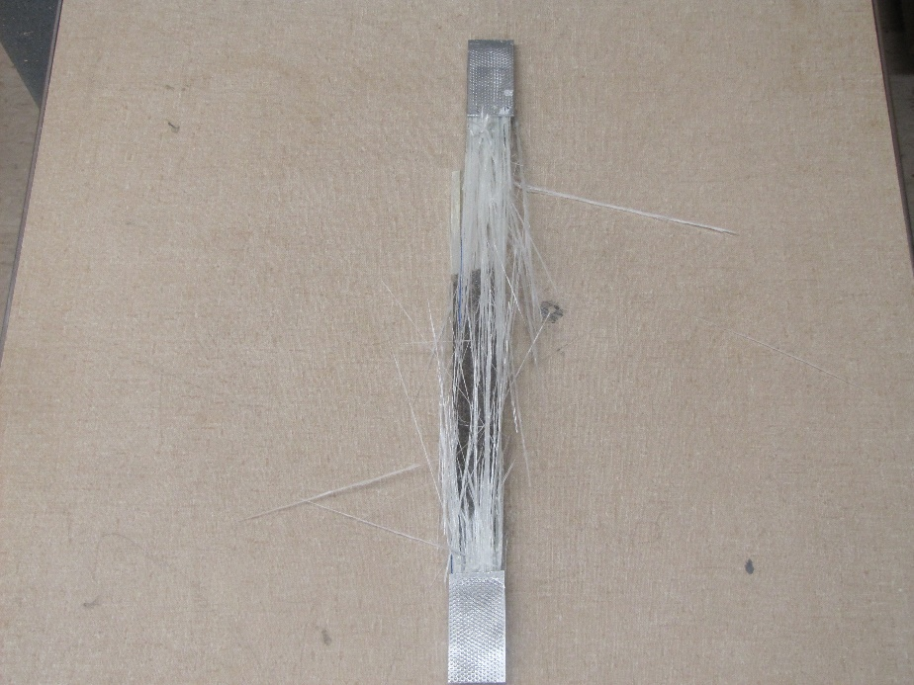

Figure 57 - Top View Fracture of Specimen 3

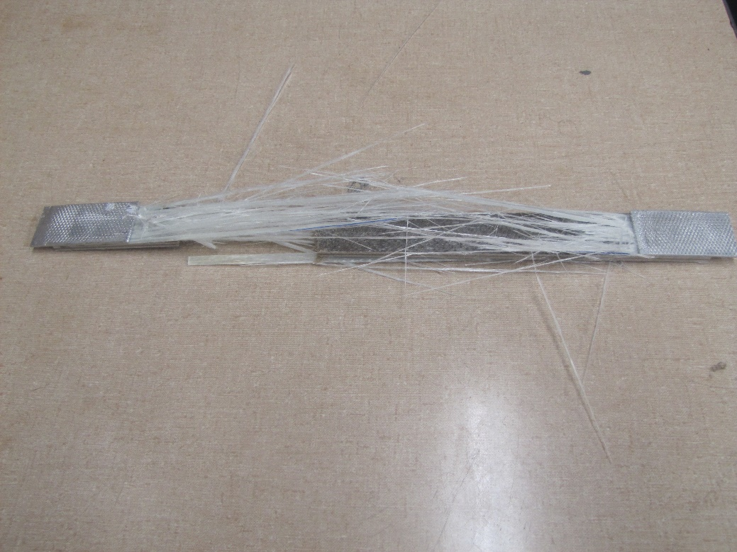

Figure 58 - Left View Fracture of Specimen 3

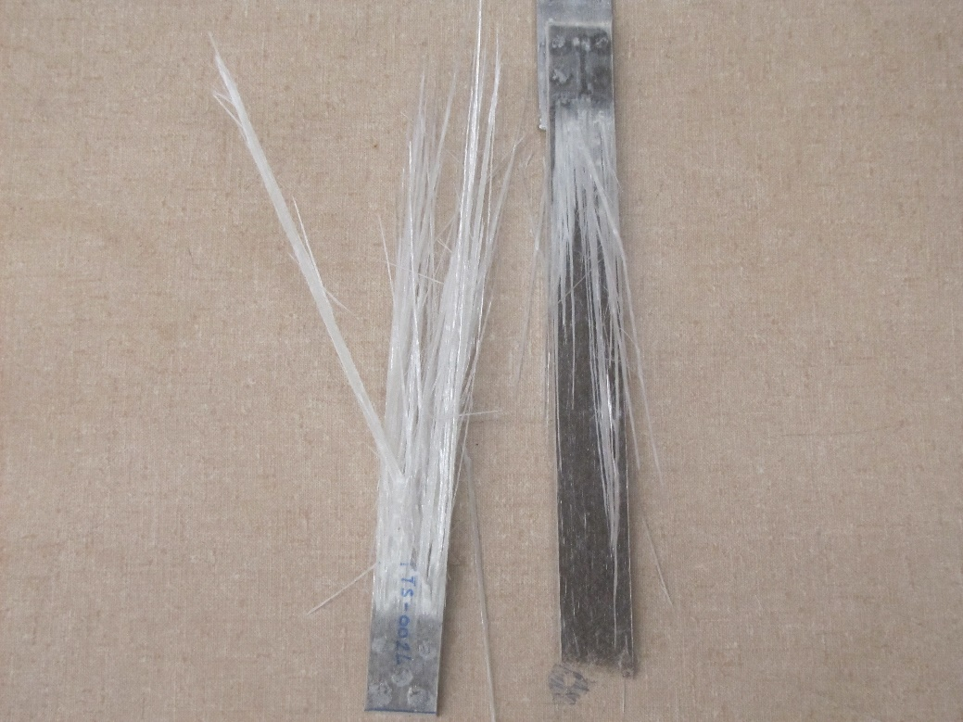

Figure 59 - Fracture of Specimen 4